**Cryptographic Applications**

**Cryptographic Applications are:**

1. Cryptography on the Internet.
2. Cryptography for wireless local area networks.
3. Cryptography for mobile telecommunications.
4. Cryptography for secure payment card transactions.
5. Cryptography for video broadcasting.

**12.1 Cryptography on the Internet**

* Cryptography on the internet uses SSL protocol.
* SSL is most important cryptographic protocols for establishing a secure network channel.
* The Internet is often modeled as a four-layer Internet Protocol Suite. SSL operates at the Transport Layer of the Internet Protocol Suite, secure channels can also be established at the higher Application Layer using the Secure Shell (SSH) protocol and at the lower Internet Layer using the Internet Protocol Security (IPsec) suite.
* SSL was developed by Netscape in the mid-1990s for use with their Navigator browser. It subsequently became the responsibility of the Internet Engineering Task Force (IETF).

**12.1.2 SSL security requirements**

SSL is designed to establish a ‘secure channel’ between two entities. The main security requirements are:

1. **Confidentiality**. Data transferred over the secure channel should only be accessible tothe entities at either end of the channel, and not by any attacker who monitors the channel.
2. **Data origin authentication**. Data transferred over the secure channel should be integrity-protected against an attacker who can conduct active attacks on the channel.
3. **Entity authentication**. In order to set up the secure channel, it should be possible to establish the identity of each communicating entity.

**12.1.3 Cryptography used in SSL**

SSL uses a wide range of cryptographic primitives:

1. Public-key cryptography is used to enable symmetric key establishment.
2. Digital signatures are used to sign certificates and facilitate entity authentication.
3. Symmetric encryption is used to provide confidentiality.
4. MACs are used to provide data origin authentication and facilitate entity authentication.
5. Hash functions are used as components of MACs and digital signatures, and for key derivation.

**SSL supports a range of different algorithms, which include:**

* Many well-known block ciphers, such as AES, normally in CBC mode.
* HMAC, implemented using a choice of well-known hash functions such as SHA-256.
* Digital signature algorithms such as RSA and DSA.

**12.1.4 SSL protocols**

SSL consists of two cryptographic protocols:

**Handshake Protocol**. This protocol performs all the tasks that require agreement between the two entities before they set up the secure SSL channel. This protocol can be used to:

* Agree on the cryptographic algorithms to be used to establish the secure Channel.
* Establish entity authentication.
* Establish the keys that will be needed to secure the channel.

**Record Protocol**. This protocol implements the secure channel. This includes:

* + Formatting the data.
  + Computing MACs on the data.
  + Encrypting the data.

**SIMPLE SSL HANDSHAKE PROTOCOL DESCRIPTION**

The message flow of the simplified SSL Handshake Protocol is indicated in Figure 12.1.

* 1. **Client Request:** This message from the client initiates the communication session and requests the establishment of an SSL-protected channel. The client sends some data, including:
  + **A session ID**, which acts as a unique identifier for the session.
  + **a pseudorandom number rC** , which will be used for the provision of freshness.
  + a list of **cipher suites** that the client supports.
  1. **Server Response:** The server responds by sending some initialization data, including:
* the session ID.
* a pseudorandom number rS, which is the server’s freshness contribution to the protocol.
* the particular cipher suite that the server has decided to use.
* a copy of the server’s public-key certificate, including details of any certificate chain required to verify this certificate.
  1. **Pre-master Secret Transfer:**

The client now generates another pseudorandom number KP, which encrypts using the server’s public key and sends to the server.

1. *rC* and *rS* are nonces used to provide freshness, hence they are not encrypted when they are exchanged.
2. KP will be used to derive the keys that are used to secure the session. This value KP is referred to as the pre-master secret and is a value known only by the client and the server.
3. **Client Finished**: The client computes a MAC on the hash of all the messages sent thusfar. This MAC is then encrypted and sent to the server.
4. **Server Finished:** The server checks the MAC received from the client. The server thencomputes a MAC on the hash of all the messages that have been sent. This MAC is then encrypted and sent to the client. The client checks the MAC received from the server.

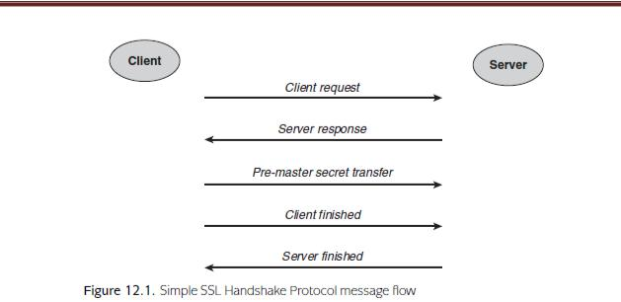

**ANALYSIS OF THE SIMPLE SSL HANDSHAKE PROTOCOL**

The simple SSL Handshake Protocol achieves its three main goals:

**Agreement of cryptographic algorithms**. This is achieved at the end of the second protocol message, when the server informs the client which cipher suite has been selected from the list provided by the client.

**Entity authentication of the server**. This relies on the following argument, assuming that the protocol run has been successful and that all checks (including certiﬁcate validity checks) have been correctly made:

* The entity who sent the Server Finished message must know the master secret KM, since the final check was correct and relied on knowledge of KM.
* Any entity other than the client who knows KM must also know the pre-master secret KP , since KM is derived from KP .
* Any entity other than the client who knows KP must know the private decryption key corresponding to the public-key certificate sent in the message Server Response, since this public key was used to encrypt KP in the message Pre- master Secret Transfer.
* The only entity with the ability to use the private decryption key is the genuine server, since the public-key certificate provided by the server in the message Server Response was checked and found to be valid.
* The server is currently ‘alive’ because KM is derived from fresh pseudorandom values (KP and rC ) generated by the client and thus cannot be an old value.

**Key establishment**. SSL establishes several keys, as we will shortly discuss. These are all derived from the master secret *KM*, which is a value that is established during the SSL Handshake Protocol. The master secret is derived from the pre-master secret *KP*, which is a value that only the client and the server know.

**SSL HANDSHAKE PROTOCOL WITH CLIENT AUTHENTICATION**

The simple SSL Handshake Protocol does not provide mutual entity authentication, only entity authentication of the server. This is reasonable because many applications do not require client authentication at the network layer where SSL is deployed.

**For example,** when a user purchases goods from an online store, the merchant may not care about who they are communicating with, so long as they get paid at the end of the transaction. In this scenario, client authentication is more likely to be performed at the application layer, perhaps by using a password-based mechanism.

The simple SSL Handshake Protocol can be modified by adding an extra message from the client to the server after the message Pre-master Secret Transfer, as follows:

**Client Authentication Data:**

The client sends a copy of its public-key certificate to the server. The public key in this certificate is used as a verification key. The certificate includes any details of the certificate chain required for verification. In addition, the client hashes all the protocol messages so far and digitally signs the hash using the client’s signature key.

The server should now check that the client’s public-key certificate (chain) is valid. The server should also verify the client’s digital signature. If these checks are successful then the server has entity authentication assurance of the client by the following argument:

1. The entity who sent the Client Authentication Data message must know the signature key corresponding to the public key in the client’s certificate, since the digital signature verified correctly.

2. The only entity who knows the signature key is the genuine client, since the public-key certificate provided by the client was checked and found to be valid.

3. The client is currently ‘alive’ because the digital signature was computed on a hash of some data that included the fresh pseudorandom value rS generated by the server, and thus cannot be a replay.

**SSL RECORD PROTOCOL**

The SSL Record Protocol is the protocol used to instantiate the secure channel after the SSL Handshake Protocol has successfully completed. Before running the SSL Record Protocol, both the client and the server derive the cryptographic data that they will need to secure the session. This includes symmetric session keys for encryption, symmetric MAC keys and any required IVs. These are all generated using a key derivation function to compute a key block. This key derivation function uses KM as a key and takes as input, amongst other data, rC and rS. The key block is then ‘chopped up’ to provide the necessary cryptographic data. In particular, the following four symmetric keys are extracted from the key block:

* KECS for symmetric encryption from the client to the server;
* KESC for symmetric encryption from the server to the client;
* KMCS for MACs from the client to the server;
* KMSC for MACs from the server to the client.

The SSL Record Protocol specifies the process for using these keys to protect traffic exchanged between the client and the server. For example, for data sent from the client to the server, the process is:

1. compute a MAC on the data (and various other inputs) using key KMCS;
2. append the MAC to the data and then pad, if necessary, to a multiple of the block length;
3. encrypt the resulting message using key KECS.

Upon receipt of the protected message, the server decrypts it using KECS and then verifies the recovered MAC using KMCS.

**12.1.5 SSL key management**

**KEY MANAGEMENT SYSTEM**

SSL essentially relies on two ‘separate’ key management systems:

**Public-key management system.** Since SSL is designed for use in open environments, it relies on an external key management system that governs the public-key pairs that are required by SSL users. This key management system is beyond the scope of an SSL specification and is relied on to establish and maintain publickey certificates and information concerning their validity. If this system fails then the security provided by SSL is undermined.

**Symmetric key management system.** Within SSL is a self-contained symmetric key management system. SSL is used to generate symmetric sessions keys, which are designed to have limited lifetimes.

**KEY GENERATION**

There are two types of keys deployed in SSL:

**Asymmetric keys**. These are generated using the public-key management system, which is not governed by the specification of SSL.

**Symmetric keys**. These are all generated within SSL. The session keys are all derived from the master secret that is established following the SSL Handshake Protocol. Key derivation is a suitable technique for key generation because:

* it is a lightweight key generation technique, which does not impose significant overheads;
* it allows several different session keys to be established from just one shared secret;
* as the SSL Handshake Protocol is relatively expensive to run (it requires the use of public-key cryptography), the shared master secret can be used to establish several batches of session keys, should this be desirable.

**KEY ESTABLISHMENT**

The most important key establishment process in SSL is the establishment of the pre-master secret during the SSL Handshake Protocol. Probably the most common technique for conducting this is to use RSA public-key encryption during the protocol message Pre-master Secret Transfer. However, a variant based on Diffie–Hellman is also supported by SSL.

**KEY STORAGE**

Key storage is beyond the scope of SSL, but it relies on both the client and the server securely storing relevant secret keys. The most sensitive keys to store are the private keys, since they are relied upon across multiple SSL sessions. In contrast, the symmetric keys negotiated during the SSL Handshake Protocol are only used for a relatively short period of time. Nonetheless, if they are compromised then so are any sessions that they are used to protect.

**KEY USAGE**

Separate encryption and MAC keys are derived from the master secret, which are then used to establish the secure channel. However, SSL takes this principle a step further by deploying separate keys for each communication direction, which provides security against reflection attacks. The cost of this is low because these separate keys are derived from the common master secret.

**12.1.6 SSL security issues**

1. **Process failures**. The most common ‘failure’ of SSL arises when a client does not perform the necessary checks to validate the server’s public-key certiﬁcate.

* A web user who is presented with a dialogue box warning them of their browser’s inability to verify a public-key certiﬁcate is quite likely to disregard it and proceed with establishing an SSL session.
* A particularly common manifestation of this problem on the Internet is when a rogue webserver, holding a legitimate public-key certiﬁcate in it so wnname,tries to pass itself off as another webserver.
* Even if the client web browser successfully veriﬁes the rogue webserver’s certiﬁcate chain, if the client does not notice that the public-key certiﬁcate is not in the name of the expected webserver then the rogue webserver will succeed in establishing an SSL protected channel with the client.
* This is an entity authentication failure because the client has succeeded in setting up an SSL session, but it is not with the server that they think it is with.
* This failure is often exploited during phishing attacks.
* It is a failure in the surrounding processes that support the protocol. In this case the client has failed to conduct a protocol action (validating the server’s certiﬁcate chain) with a sufﬁcient degree of rigour.

1. **Implementation failures**.

Because it is an open protocol that can be adopted for many different applications, on different platforms, by anyone, SSL is particularly vulnerable to implementation failures. Even if the protocol speciﬁcation is followed correctly, it could fail if a supporting component is weak.

**For example,** if the client uses a weak deterministic generator to generate the pre-master secret *KP* then the protocol can be compromised because the session keys become too predictable.

1. **Key management failures**. If either the client or the server mismanages their cryptographic keys then the protocol can be compromised.

**For example,** if an attacker obtains the server’s private key then the attacker can recover the pre-master secret. The attacker can then compute all the resulting session keys and hence undermine any secure channel that these session keys are used to establish.

1. **Usage failures**. SSL has such a high proﬁle that it runs the risk of being used inappropriately. Alternatively it may be appropriately deployed, but its security properties overestimated under the misapprehension that use of SSL ‘guarantees’ security.

**12.1.7 SSL design issues**

**Support for a range of publicly known cryptographic algorithms**.

Since SSL(in this case were ally mean TLS) is an open standard targeted at wide-scale public use, it is fundamental that it supports not just publicly known algorithms, but a *range of* publicly known algorithms. This supports cross-platform use and has helped to foster conﬁdence in SSL as a protocol.

**Flexibility**. SSL is not only ﬂexible in terms of the components that can be used to implement it, but it is also ﬂexible in the ways in which it can be used (for example, to provide unilateral or mutual entity authentication). This, again, is because SSL has been targeted at a wide range of application environments.

**Minimal use of public-key operations**. The use of hybrid encryption restricts the number of public-key operations to the minimum necessary to establish a secure channel. Although we have not discussed this in any detail, SSL is also designed so that the relatively expensive SSL Handshake Protocol may not need to be rerun if a client requires another session with the same server within a speciﬁed time period.

**Unbalanced computational requirements: I**n the SSL Handshake Protocol it is the client who is required to generate the pre-master secret and send it encrypted to the server. This means that the client performs one public- key *encryption* operation and the server performs one public-key *decryption* operation. One reason for this is that some public-key cryptosystems, and RSA is a good example, have certain public keys that are considerably more computationally efﬁcient to use than others.

**12.2 Cryptography for wireless local area networks**

**12.2.1 WLAN background**

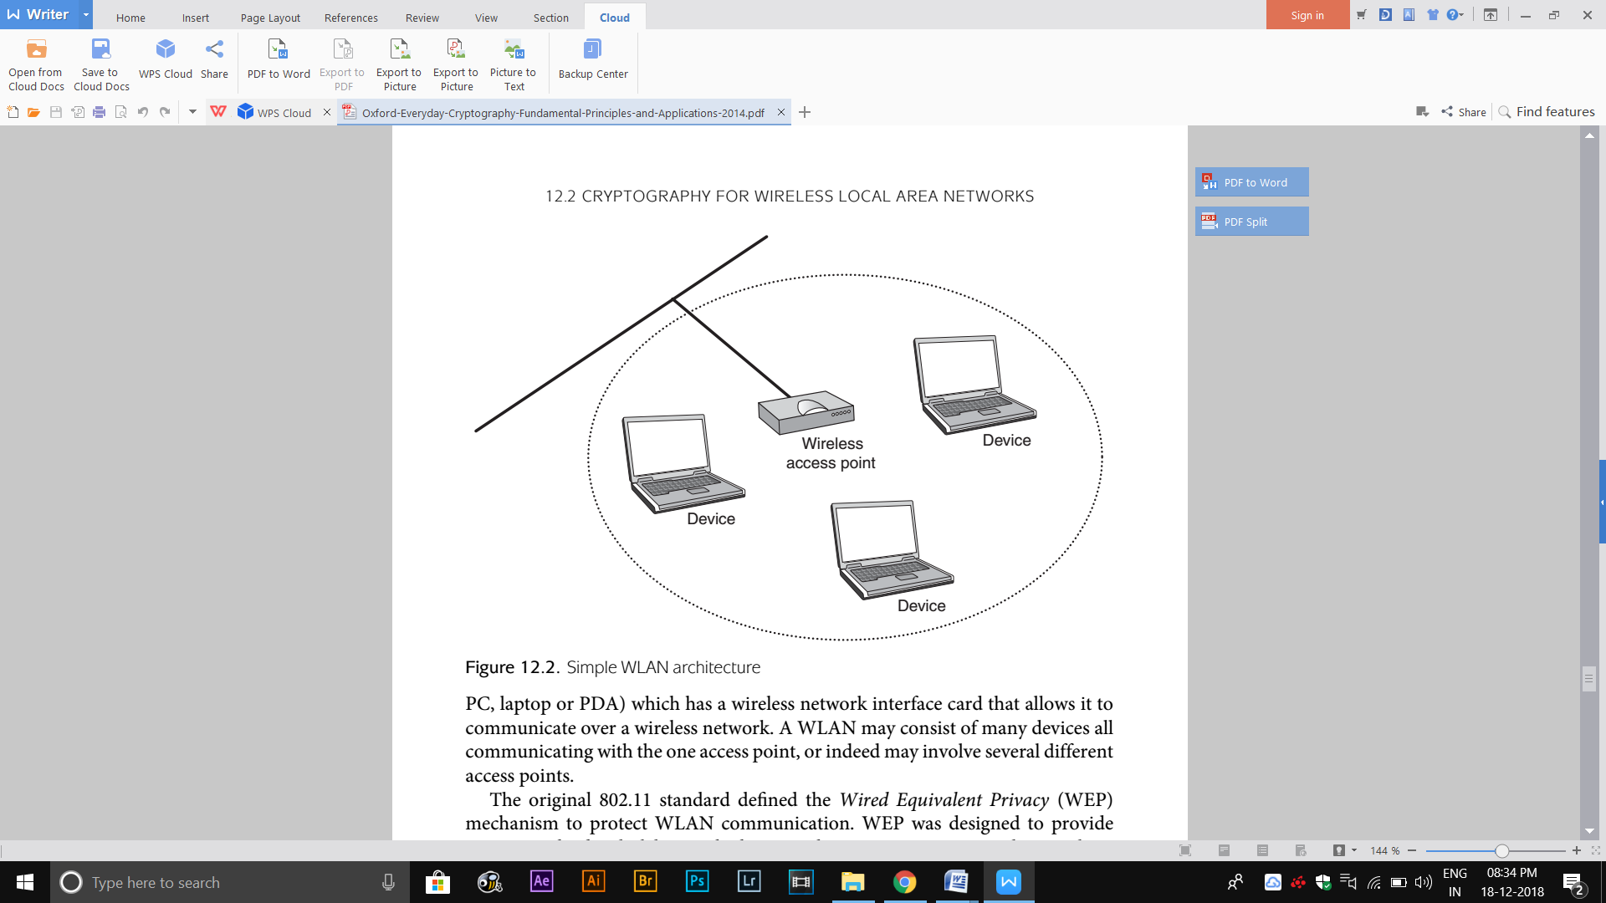

A simple WLAN architecture is shown in Figure 12.2.

* A wireless access point is a piece of hardware that acts as a bridge between the wireless network and a wired network (for example, the wired network that delivers a connection to the Internet from a home).
* The access point consists of a radio, an interface with the wired network and bridging software.
* A device is any computer (for example, a desktop PC, laptop or PDA) which has a wireless network interface card that allows it to communicate over a wireless network.
* A WLAN may consist of many devices all communicating with the one access point, or indeed may involve several different access points.
* The original 802.11 standard defined the Wired Equivalent Privacy (WEP) mechanism to protect WLAN communication. WEP was designed to provide security at the data link layer, which means that it operates at a virtual networking layer that is close to being the equivalent of physical wires in a wired network.
* An improved security mechanism known as Wi-Fi Protected Access (WPA) was designed as a solution.

**12.2.2 WLAN security requirements**

The security requirements for a WLAN are:

**Confidentiality.** Data transferred over the WLAN should be kept confidential..

**Mutual entity authentication.** Communicating entities can identify one another when setting up a WLAN connection. This is motivated by the fact that a degree of inherent (very weak) ‘entity authentication’ is provided by physical wires, but there are no such guarantees once we are in a wireless environment.

**Data origin authentication.** The source of all data transferred over the WLAN should be assured. This is because an attacker could easily modify data transmitted during a WLAN session after the initial entity authentication has been conducted. The original WLAN security standard WEP only provides a weak level of data integrity, which is not good enough.

**12.2.3 WEP**

There are three cryptographic design decisions that are common to all of the WLAN security mechanisms

• Since WLANs may be comprised of many different types of device, from different manufacturers, it is important that the cryptography used in a WLAN is widely available. Hence it would not be wise to deploy proprietary cryptographic algorithms.

• Since these mechanisms are dedicated to WLAN security and do not require the full flexibility of the likes of SSL, it makes sense to decide which cryptographic algorithms to use in advance and then deploy them universally, rather than require an expensive equivalent of the SSL Handshake Protocol to negotiate them.

• Since speed and efficiency are important, and WLANs are usually linked to some sort of fixed infrastructure, symmetric cryptography is a natural choice.

**CONFIDENTIALITY AND INTEGRITY MECHANISMS IN WEP**

The first WEP design decision was to use a shared, fixed symmetric key in each WLAN. This same key is used by all devices, for several different purposes, when communicating using a WEP-secured WLAN. This almost eliminates any issues regarding key establishment, however, it introduces considerable risks. In particular, if one of the devices is compromised then this key may become known to an attacker, and hence the entire network will be compromised. The original version of WEP only used a 40-bit key, but later adaptations allow much longer keys.

One problem with deploying a stream cipher such as RC4 is the need for synchronisation, especially in a potentially noisy channel such as a wireless one. Thus WEP requires each packet of data to be encrypted separately, so that loss of a packet does not affect the rest of the data being sent. This introduces a new problem. the negative consequences of re-using keystream for more than one plaintext. It follows that WEP requires a mechanism for making sure that the same keystream is not reused for subsequent packets.

**The solution** to this problem in WEP was to introduce an initialisation vector (IV), which just like the IVs used in several of the modes of operation of a block cipher, varies each time the WEP key is used to encrypt a packet. However, RC4 does not easily allow an IV to be incorporated into the encryption process, hence the WEP IV is directly appended to the key. In this way WEP defines a ‘per-packet’ key, which consists of a 24-bit IV appended to the WEP key. If Alice wants to set up a secure WLAN connection with Bob, based on the shared, fixed WEP key K, the encryption process for each packet of data to be sent is depicted in Figure 12.3 and is as follows.

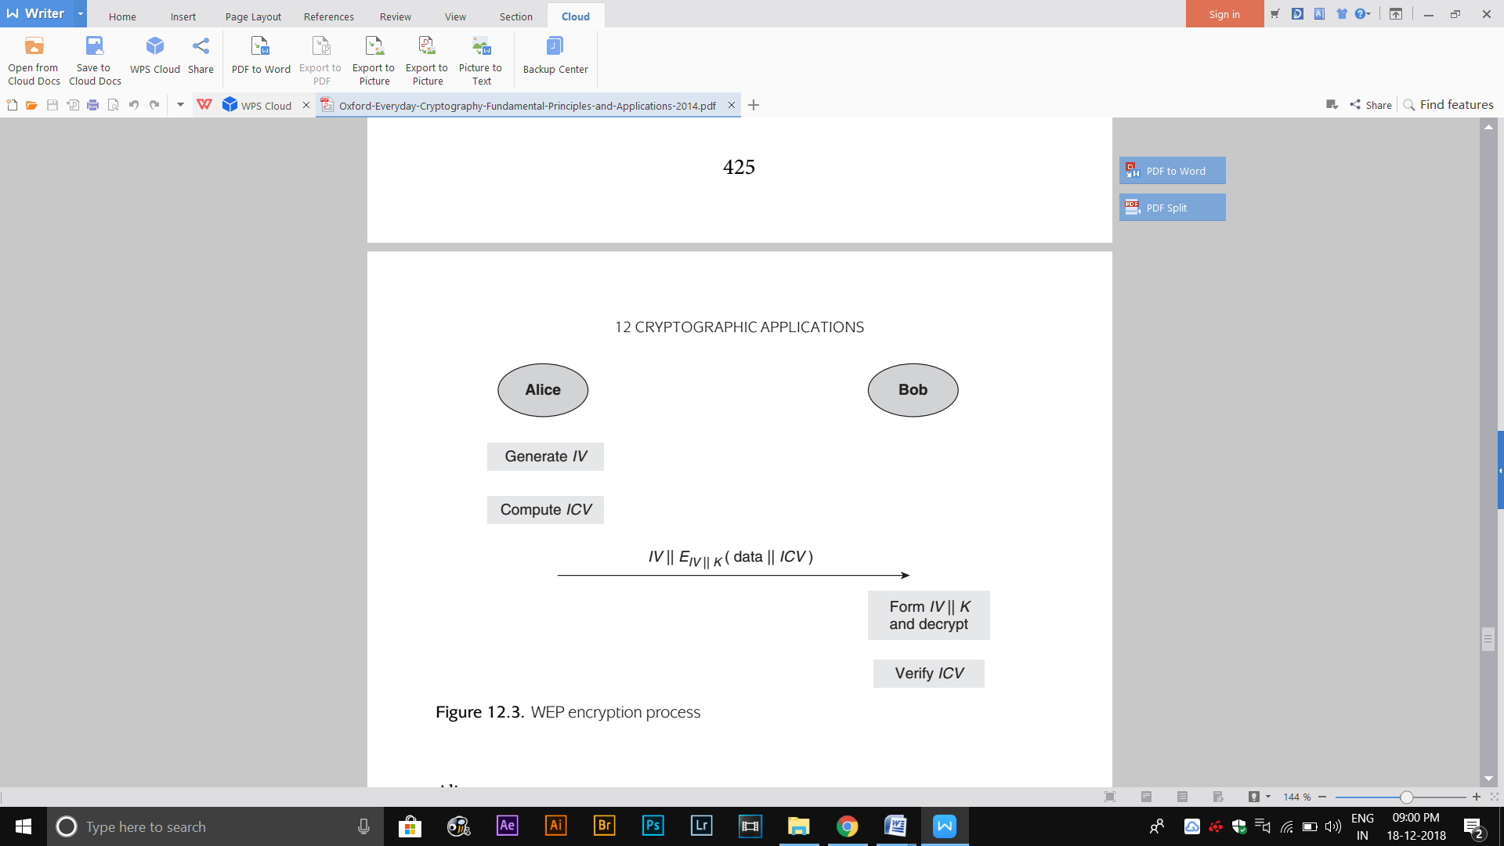

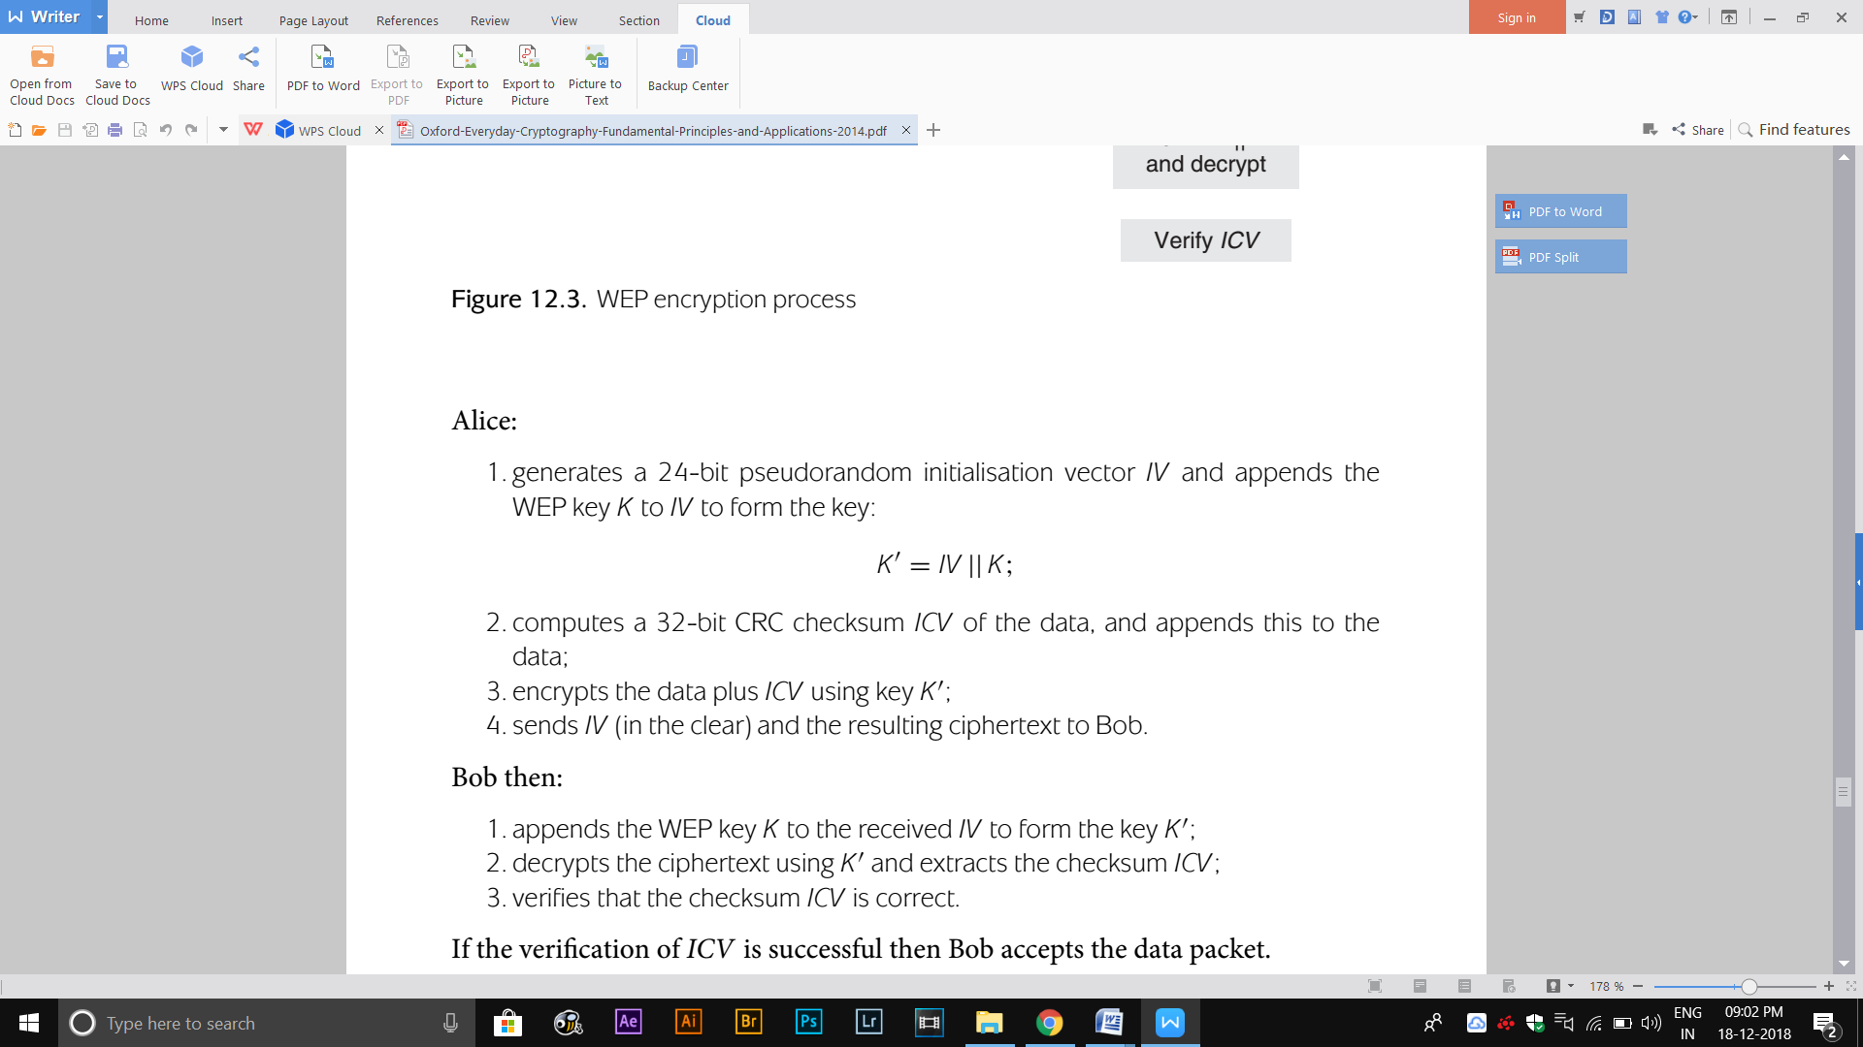

**ENTITY AUTHENTICATION IN WEP**

The WEP entity authentication technique is very simple. It is based on the challenge–response principle If Alice (a device) wants to identify herself to Bob (a wireless access point):

1. Alice sends a request to authenticate to Bob;

2. Bob sends a nonce rB to Alice;

3. Alice uses WEP encryption to encrypt rB (importantly for later, note from our above explanation of the WEP encryption process that this also involves Alice generating an IV that is used to ‘extend’ the WEP key).

4. Alice sends the IV and the resulting ciphertext to Bob;

5. Bob decrypts the ciphertext and checks that it decrypts to rB; if it does, he authenticates Alice.

**12.2.4 Attacks on WEP**

**WEP KEY MANAGEMENT WEAKNESSES**

There are several serious problems with WEP key management:

* **Use of a shared fixed key**: The WEP key K acts as an overall ‘master key’ for the WLAN and, as such, is a single point of failure. If the WEP key can be compromised (and it suffices that this compromise arises on just one of the entities forming the WLAN) and an attacker learns the WEP key then the entire WLAN security is compromised.
* **Exposure of the WEP key**. In its role as a master key, the WEP key is unnecessarily ‘exposed’ through direct use as a component of an encryption key. It is also exposed in this way each time an authentication attempt is made.
* **No key separation**.WEP abuses the principle of key separation by using the WEP key for multiple purposes.
* **Key length**. While WEP does allow the WEP key length to vary, the smallest RC4 key length is 40 bits, which is far too short to be secure against contemporary exhaustive key searches. Many WEP implementations allow WEP keys to be generated from passwords which, if not long enough, reduce the effective keyspace that an attacker needs to search.

**WEP ENTITY AUTHENTICATION WEAKNESSES**

Attacks concerning the entity authentication mechanism.

**Rogue wireless access point.** WEP only provides unilateral entity authentication from a device (Alice) to a wireless access point (Bob). This means that an attacker could set up a rogue access point and allow Alice to authenticate to it, without Alice realising that she was not dealing with the genuine access point.

**Lack of session key.** WEP does not establish a session key during entity authentication that is later used to protect the communication session. As a result, WEP entity authentication is only valid for the ‘instant in time’ at which it is conducted. WEP thus suffers from the potential for a ‘hijack’ of the communication session.

**Keystream replay attack**. Another serious problem is that there is no protection against replays of the WEP authentication process. An attacker who observes Alice authenticating to Bob is able to capture a plaintext (the challenge rB and its CRC checksum) and the resulting ciphertext (the encrypted response). Since WEP uses the stream cipher RC4, the keystream can be recovered by XORing the plaintext to the ciphertext. We will denote this keystream by KS(IV || K), since it is the keystream produced by RC4 using the encryption key IV || K. Good stream ciphers are designed to offer protection against an attacker who knows corresponding plaintext/ciphertext pairs, and hence can recover keystream from this knowledge. However, this relies on the same keystream not being reused in a predictable manner . This is where WEP fails, since the attacker can now falsely authenticate to Bob as follows (and depicted in Figure 12.4):

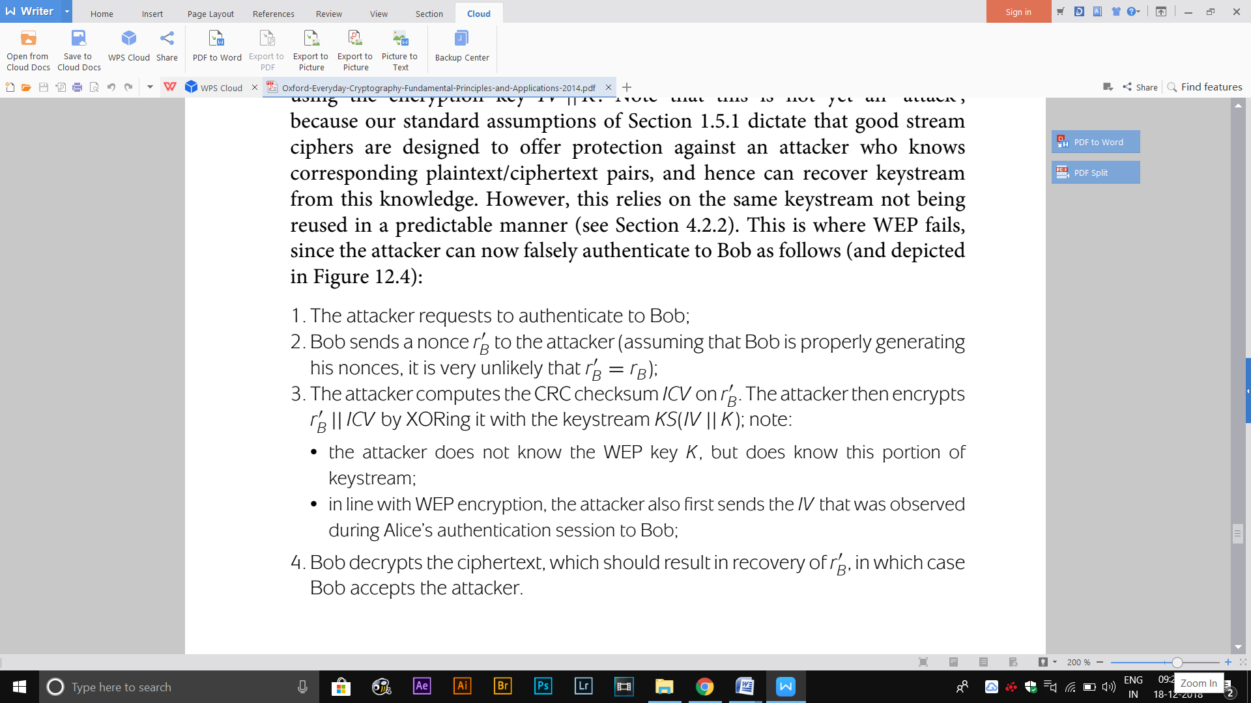

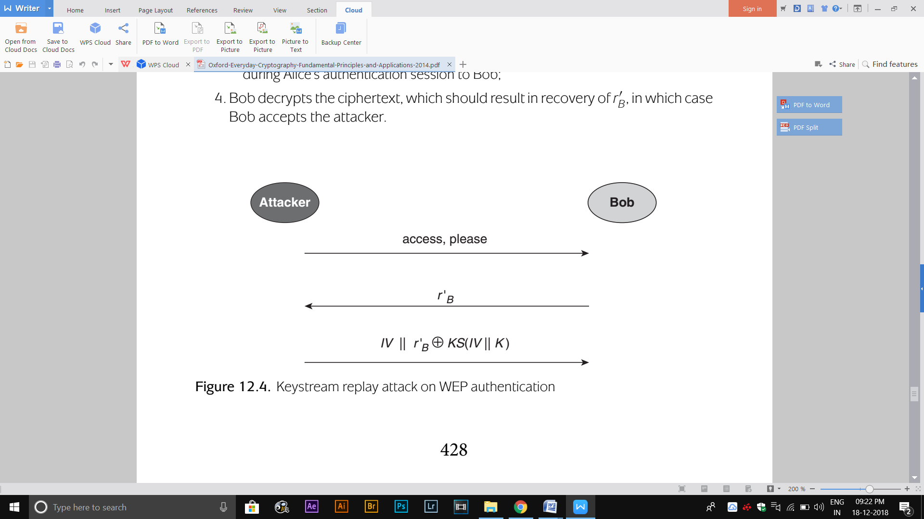

This attack works because WEP allows the attacker to ‘force’ Bob to use the same IV that Alice used in the genuine authentication session, and hence use the same encryption key IV || K, which in turn validates the use of the previous keystream. Of course, having authenticated to the access point, the attacker cannot do much more since the attacker still does not know the WEP key K and hence cannot perform valid encryptions and decryptions. Nonetheless, the authentication process has been successfully attacked.

**12.2.5 WPA and WPA2**

MUTUAL ENTITY AUTHENTICATION AND KEY ESTABLISHMENT

In order to avoid all the problems relating to use of a shared, fixed WEP key, a key hierarchy is employed. The top key in this key hierarchy is known as the pairwise master key PMK, which is a key that is shared between a device and a wireless access point. There are two ways in which this key PMK can be established:

1. During an AKE protocol that is run between a device and a central authentication server. Both WPA and WPA2 support the use of a central authentication server to provide authentication in a way that is scalable and can be tailored to fit the needs of the specific application environment. A wide range of authentication techniques are supported by the Extensible Authentication Protocol (EAP), which is a suite of entity authentication mechanisms that includes methods that deploy SSL to secure a connection to an authentication server.

2. As a pre-shared key that is programmed directly into the device and the wireless access point. This is most suitable for small networks. The most common method for generating PMK is by deriving it from a password. Any users requiring access to the WLAN must be made aware of this password. A home user who purchases a wireless router may be provided with a (weak) default password from the manufacturer or service provider. It is important that this is changed on first installation to something less predictable.

The master key PMK is also used to derive session keys using the following AKE protocol that runs between Alice (a device) and Bob (a wireless access point) and is shown in Figure 12.5:

1. Alice generates a nonce rA and sends rA to Bob.

2. Bob generates a nonce rB. Bob then uses rA, rB and PMK to derive the following four 128-bit session keys:

• an encryption key EK;

• a MAC key MK;

• a data encryption key DEK;

• a data MAC key DMK

3. Bob then sends rB to Alice, along with a MAC computed on rB using MAC key MK.

4. Alice uses rA, rB and PMK to derive the four session keys. She then checks the MAC that she has just received from Bob.

5. Alice sends a message to Bob stating that she is ready to start using encryption. She computes a MAC on this message using MAC key MK.

6. Bob verifies the MAC and sends an acknowledgement to Alice.

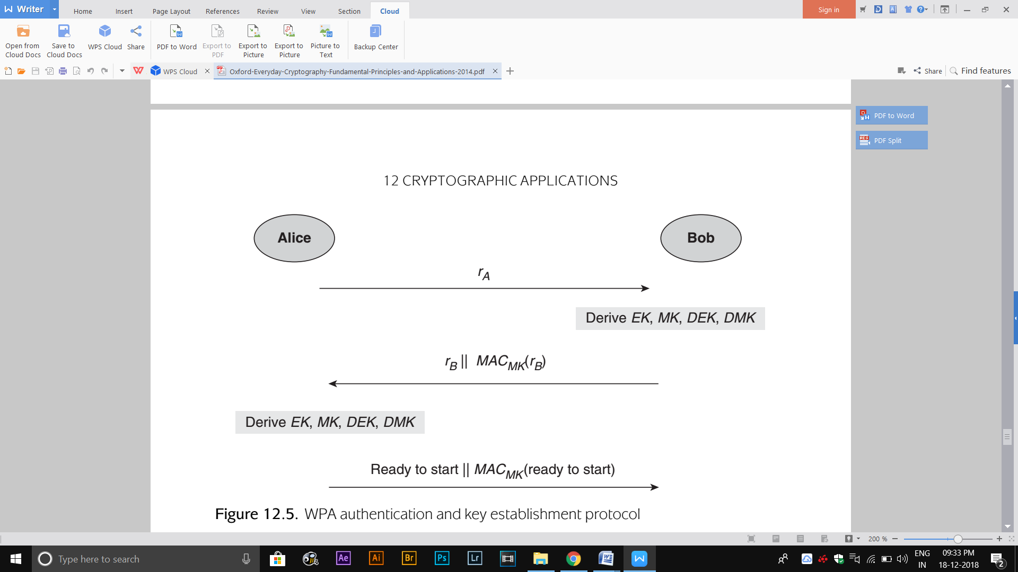

**12.2.7 WLAN design issues**

The main cryptographic design issues concerning WLAN security are as follows:

* **Use of symmetric cryptography**. This is a sensible decision because WLANs transfer bulk traffic between networked devices, hence speed of encryption is important. For small networks, such as a home network, key establishment is straightforward. Larger enterprise WLANs may optionally choose to use public-key mechanisms as part of the initial authentication between a device and a central authentication server, but the core WPA2 security protocol CCMP uses only symmetric cryptography.
* **Use of recognised cryptographic mechanisms.** This was not adhered to in WEP, where the cryptographic design was rather ad hoc. WEP thus provides a useful lesson regarding the potential folly of adopting unconventional mechanisms. In contrast, WPA2 adopts more widely accepted cryptographic mechanisms.
* **Flexibility, but only when appropriate.** While WLANs may be deployed in quite different environments, they do not require the same cryptographic flexibility as open applications such as SSL. Thus it makes sense to ‘lock down’ the cryptographic mechanisms, where appropriate. WPA2 does this for the confidentiality and data origin authentication services. However, WPA2 allows for flexibility in choosing the initial entity authentication mechanism (between the device and a centralised authentication server), recognising that different environments may well have different approaches to identifying network users.
* **The potential need to cater for migration.** When the flaws in WEP became apparent, it was clear that due to the difficulty of upgrading a widely deployed technology, any complete redesign of the WLAN security mechanisms could not be rolled out quickly. It was thus necessary to design a ‘fix’ that was based on the existing cryptographic mechanisms, which would provide ‘good enough’ security. The ‘fix’ is WPA, which is based on RC4. The ‘complete redesign’ is WPA2, which is based on AES.

**12.3 Cryptography for mobile telecommunications**

**12.3.1 GSM and UMTS background**

* The shift from analogue to digital communications brought with it the opportunity to use cryptographic techniques to provide security. In doing so, the development of the Global System for Mobile Communication (GSM) standard by the European Telecommunications Standards Institute (ETSI) brought security to mobile telecommunications.
* Third generation, or 3G, mobile phones are characterised by higher data transmission rates and a much richer range of services. The enhanced security of GSM’s successor for 3G phones, the Universal Mobile Telecommunications System (UMTS).
* The basic architecture of a mobile telecommunications network is shown in Figure 12.6. The network is divided into a large number of geographic cells, each of which is controlled by a base station. A mobile phone first connects with its nearest base station, which directs communications either to the home network of the mobile phone user or to other networks in order to transfer call data.

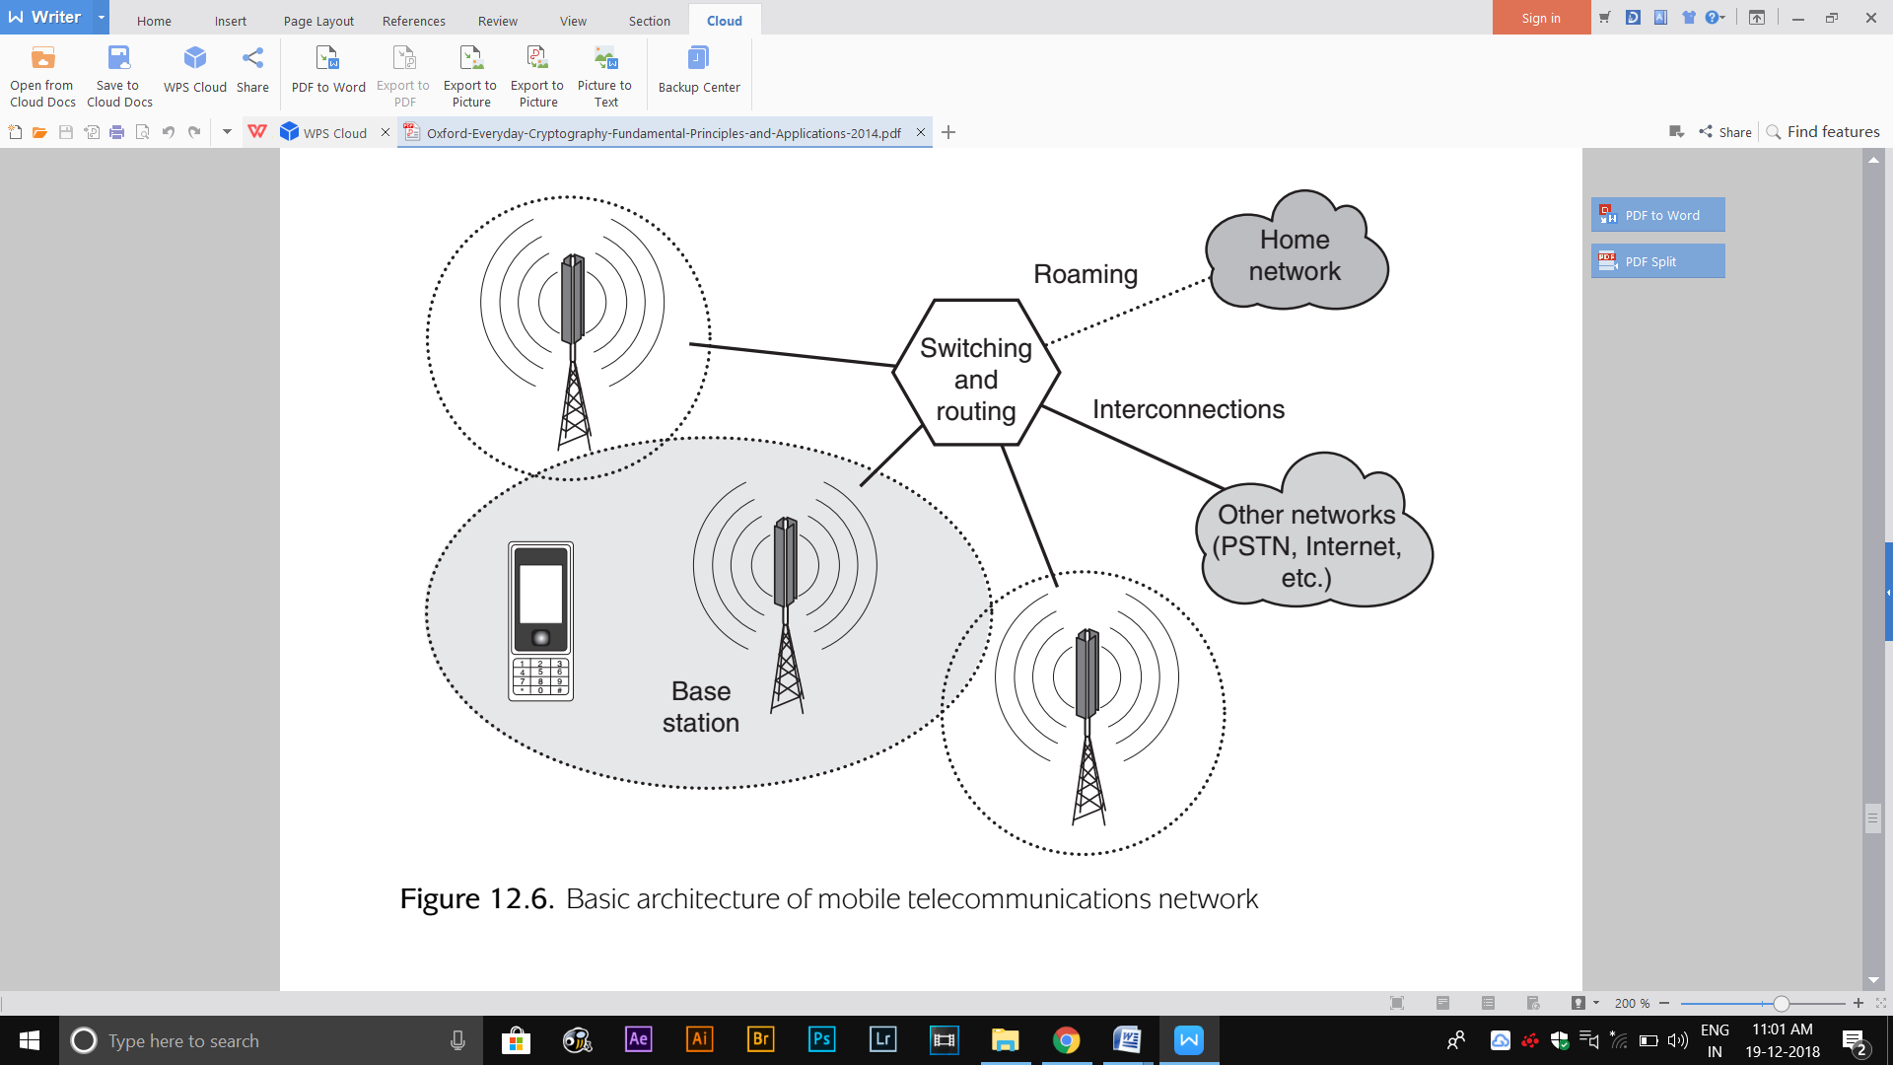

**12.3.2 GSM security requirements**

The following are the specific security requirements:

* **Entity authentication of the user**. Mobile operators need to have strong assurance of the identity of users connecting with their services in order to reduce fraud. This issue is much simpler to deal with in traditional telephone networks, since a user needs to have physical access to the end of a telephone wire in order to use the services.
* **Confidentiality on the radio path.** In simple terms, a mobile connection passes ‘over the air’ (the radio path) between the handset and a base station, after which it is passed through a switching centre and enters the traditional PSTN (see Figure 12.6). Thus in order to provide ‘PSTN-equivalent security’, the main link for which GSM needs to provide additional security is the radio path. Since this path is easily intercepted by anyone with a suitable receiver it is necessary to provide confidentiality on this radio path.
* **Anonymity on the radio path**. GSM provides a degree of anonymity (confidentiality of the identity of users) on the radio path in order to prevent an attacker from linking the source of several intercepted calls. This is handled by using temporary user identities for each call, rather than permanent ones.

**12.3.3 Cryptography used in GSM**

The main cryptographic design decisions for GSM were:

* **A fully symmetric cryptographic architecture**.GSM is an entirely closed system. All key material can be loaded onto the necessary equipment prior to it being issued to users, so there is no need to use public-key cryptography for this purpose.
* **Stream ciphers for data encryption**. The requirement for fast real-time encryption over a potentially noisy communication channel means that, a stream cipher is the most appropriate primitive.
* **Fixing the encryption algorithms**. It is necessary that the mobile operators agree on which encryption algorithms to use, so that the devices on which they operate can be made compatible with one another. However, other cryptographic algorithms, such as those used in GSM authentication, donot have to be ﬁxed. In the case of authentication, an individual mobile operator is free to choose the cryptographic algorithm that it deploys to authenticate its own users(since users of another mobile operator are not directly impacted by this decision).
* **Proprietary cryptographic algorithms**. The designers of GSM chose to develop some proprietary cryptographic algorithms, rather than use open standards. While the use of proprietary algorithms is not wise in many application environments, in the case of GSM there were three factors that favoured at least considering this option:
* GSM is a closed system, hence deploying proprietary algorithms is feasible.
* ETSI have a degree of cryptographic expertise, and maintain links with the open research community.
* The need for fast real-time encryption means that an algorithm designed explicitly to run on the hardware of a mobile phone will probably perform better than an ‘off-the-shelf’ algorithm.

**SIM:** The fundamental component involved in GSM security is the *Subscriber Identiﬁcation Module* (SIM) *card*, which is a smart card that is inserted into the mobile phone of the user. This SIM card contains all the information that distinguishes one user account from another. As a result, a user can potentially change phone equipment simply by removing the SIM and inserting it into a new phone. The SIM contains two particularly important pieces of information:

1. The *International Mobile Subscriber Identity* (IMSI), which is a unique number that maps a user to a particular phone number;
2. A unique 128-bit cryptographic key *Ki*, which is randomly generated by the mobile operator.

These two pieces of data are inserted onto the SIM card by the mobile operator before the SIM card is issued to the user. The key *Ki* forms the basis for all the cryptographic services relating to the user. The SIM card also contains implementations of some of the cryptographic algorithms required to deliver these services.

**GSM AUTHENTICATION**

* Entity authentication of the user in GSM is provided using a challenge–response protocol, This is implemented as part of an AKE protocol, which also generates a key *Kc* for subsequent data encryption.
* GSM does not dictate which cryptographic algorithms should be used as part of this AKE protocol, but it does suggest one candidate algorithm and deﬁnes the way in which algorithms should be used.
* As indicated in Figure12.7, an algorithm A3 is used in the challenge–response protocol and an algorithm A8 is used to generate the encryption key *Kc*.
* Both of these algorithms can be individually selected by the mobile operator and are implemented on the SIM and in the operator’s network.
* Both A3 and A8 can be loosely considered as types of key derivation function, since their main purpose is to use *Ki* to generate pseudorandom values.

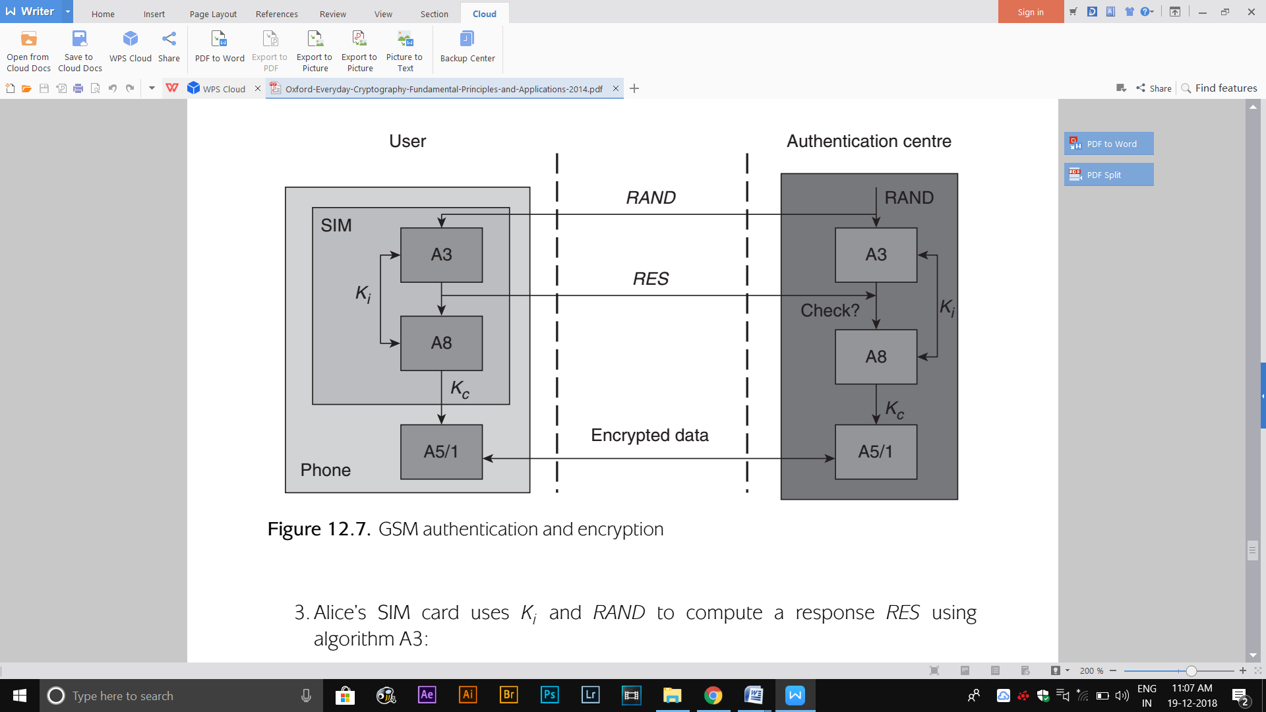

The notation *A*3*K* (*data*) to denote the result of computing algorithm A3 on the input *data* using key *K* (the notation *A*8*K* (*data*) should be similarly interpreted). If Alice (a mobile) is able to directly authenticate to Bob (the authentication centre of a mobile operator) then the GSM AKE protocol is as follows:

1. Alice sends an authentication request to Bob.
2. Bob generates a 128-bit randomly generated challenge number *RAND* and sends it Alice.
3. Alice’s SIM card uses *Ki* and *RAND* to compute a response *RES* using algorithmA3:

*RES* = *A*3*Ki* (*RAND*)*.*

The response *RES* is sent back to Bob.

1. Bob, who maintains a database of all the user keys, selects the appropriate key Ki for Alice and then computes the expected response in the same way. If the result matches the received *RES* then Alice is authenticated.
2. Alice and Bob both use *Ki* and *RAND* to compute an encryption key *Kc* using algorithm A8:

*Kc* = *A*8 *Ki* (*RAND*)*.*

This simple protocol relies on the belief that only the mobile user and the mobile operator authentication centre can possibly know the key *Ki* that has been installed on the user’s SIM card.

**GSM ENCRYPTION**

* While authentication is a service that is ‘private’ to a mobile user and their mobile operator, encryption must be provided using a mechanism that is common to all mobile operators, in order to facilitate cross-network calls.
* Thus the encryption algorithm A5/1 is ﬁxed by the GSM standard (in fact GSM offers three different versions of A5, but A5/1 is the most commonly deployed). As indicated in Figure 12.7, it is implemented on the mobile phone itself, not the SIM card, since the phone has more computation power than the SIM.
* The A5/1 algorithm is a stream cipher with a 64-bit key. It was designed to be implemented very efﬁciently in the hardware of a mobile phone.
* In GSM, A5/1 is used to encrypt all radio path communication (both signalling information and the message data) using the key *Kc*. Potentially, this key maybe freshly generated each time a user makes a mobile call.
* Encryption is also used to protect the transfer of temporary identiﬁcation numbers, which are used instead of the IMSI to provide user anonymity.

**FACILITATING GSM ROAMING**

**Scenario :** when a mobile user is traveling outside the area serviced by their mobile operator, for example, overseas (this is referred to as roaming). Although different mobile operators are in some sense part of a wider ‘closed’ GSM network, they are still individual businesses with their own private user relationships. It would thus be unacceptable for one operator to share its security critical data (particularly key Ki) with another for the purpose of facilitating roaming. On the other hand, it is equally unacceptable from a practical perspective for every authentication request from a roaming user to be referred back to the user’s mobile operator, since this might result in extensive delays.

**Solution**: GSM has a solution to this problem, through the use of authentication triplets. When a roaming mobile user Alice first connects with Charlie, a local mobile operator with whom she has no direct business relationship, the following procedure is followed:

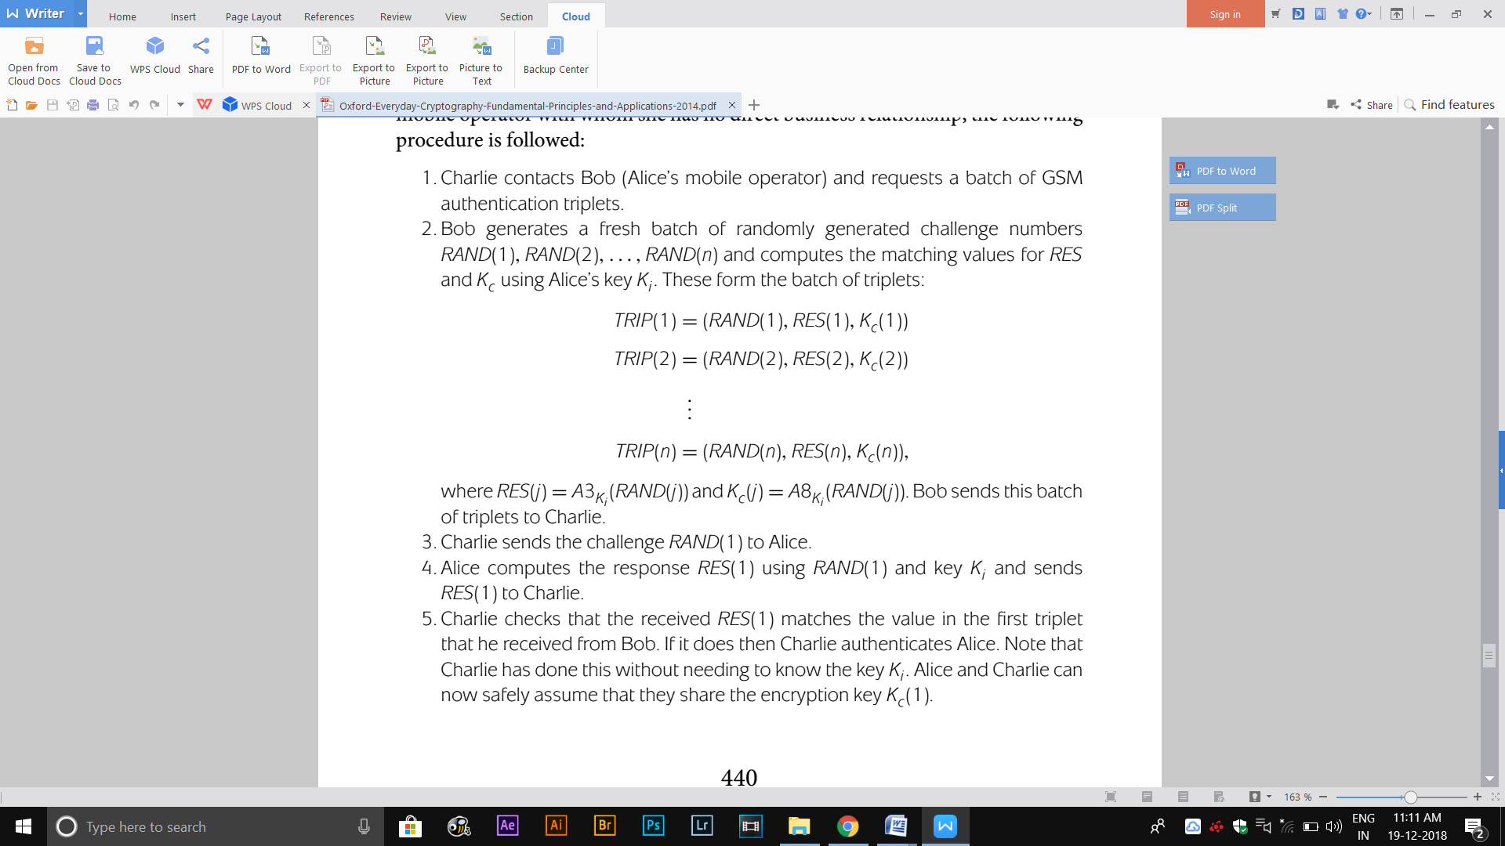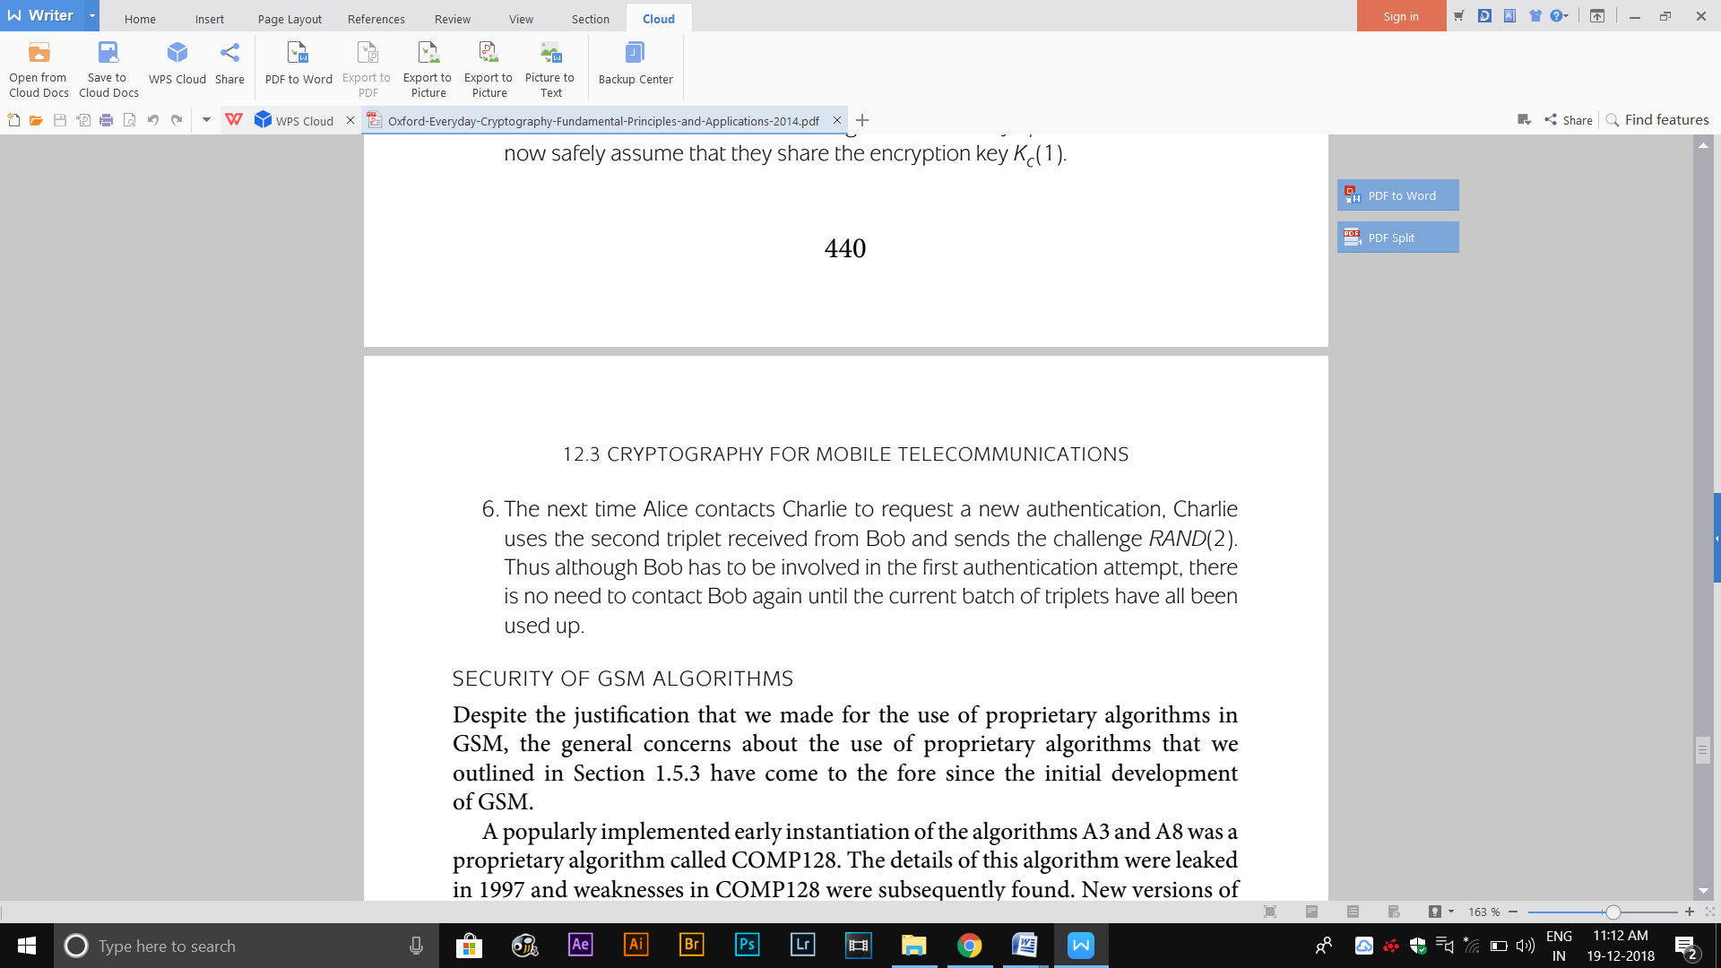

**12.3.4 UMTS**

The main cryptographic improvements over GSM are as follows:

* **Mutual entity authentication**. GSM offers entity authentication only of the mobile user. Since the development of GSM, so-called false base station attacks have become much more feasible due to reductions in the costs of suitable equipment. In one example of such an attack, a mobile user connects to the false base station, which immediately suggests to the user that encryption is turned off. By additionally requiring the user to authenticate to the mobile base station, such attacks are prevented.
* **Prevention of triplet reuse.** A GSM triplet can be reused many times for the particular mobile that it was generated for. In UMTS this is prevented by upgrading authentication triplets to quintets, which additionally include a sequence number that prevents successful replay and a MAC key.
* **Use of publicly known algorithms**. UMTS adopts cryptographic algorithms based on well-established and well-studied techniques. While it does not quite use ‘off-the-shelf’ algorithms, due to the desire to tailor algorithms to the underlying hardware, the algorithms deployed are very closely based on standard algorithms and the modifications have been publicly evaluated.
* **Longer key lengths**. Following the relaxation of export restrictions that were in place at the time of GSM development, the key lengths of the underlying cryptographic algorithms were increased to 128 bits.
* **Integrity of signalling data.** UMTS provides additional integrity protection to the critical signalling data. This is provided using a MAC, whose key is established during the UMTS authentication (AKE) protocol.

**12.3.5 GSM and UMTS key management**

**KEY MANAGEMENT SYSTEM**

GSM and UMTS have an entirely symmetric key management system, facilitated by the fact that a mobile operator is completely in control of all keying material relating to their users. Underlying key management system as a very simple key hierarchy with the user keys Ki acting as individual user ‘master keys’ and the encryption keys Kc acting as data (session) keys.

**KEY GENERATION**

The user keys Ki are randomly generated, normally by the SIM manufacturer (on behalf of the mobile operator) using a technique of their choice. The encryption keys Kc are derived from the user keys Ki, using the mobile operator’s chosen cryptographic algorithm.

**KEY ESTABLISHMENT**

The establishment of user key Ki is under the control of the SIM manufacturer (on behalf of the mobile operator) who installs Ki on the user’s SIM card before it is issued to the user. The significant key management advantage that is being exploited here is that a mobile service has no utility until a customer obtains a physical object from the mobile operator (in this case a SIM card), hence key establishment can be tied to this process. The keys Kc are established during the AKE protocol used for entity authentication. It is clearly very important that the SIM manufacturer transfers all the keys Ki to the mobile operator using highly secure means, perhaps in the form of an encrypted database.

**KEY STORAGE**

The critical user keys Ki are stored in the hardware of the user’s SIM card, which offers a reasonable degree of tamper-resistance. Only the encryption key Kc, and in UMTS a MAC key derived from Ki, leave the SIM card. These are session keys that are discarded after use.

**KEY USAGE**

Both GSM and UMTS enforce a degree of key separation by making sure that the long-term user key Ki is only ever indirectly ‘exposed’ to an attacker through its use to compute the short responses to the mobile operator’s challenges. The key Kc that is used for bulk data encryption, and is thus most ‘exposed’ to an attacker, is a derived key that is not used more than once. In UMTS, separate keys for encryption and MACs are derived from Ki. The use of a SIM also makes key change relatively straightforward.

**12.3.7 GSM and UMTS design issues**

The main design issues emerging from our study of GSM and UMTS are the following:

**Use of symmetric cryptography.** The closed nature of the application environment lends itself to adoption of a fully symmetric solution. The properties of stream ciphers are highly suited to mobile telecommunications.

**Adaptation to evolving constraints.** GSM was designed under several constraints, including cryptographic export restrictions and the apparent lack of a need for mobile operator authentication. As the environment determining these constraints evolved, the redesigned security mechanisms of UMTS took these into account.

**Shift from proprietary to publicly known algorithms.** Mobile telecommunications provide a plausible environment for the adoption of proprietary cryptographic algorithms. However, subsequent weaknesses in some of the original GSM algorithms may well have influenced the use of publicly known algorithms in UMTS.

**Flexibility, but only when appropriate.** GSM and UMTS only prescribe particular cryptographic algorithms when this is essential, leaving a degree of flexibility to mobile operators. That said, in UMTS mobile operators are strongly encouraged to follow central recommendations.

**12.4 Cryptography for secure payment card transactions**

* Financial sector organisations are the most established commercial users of cryptography.
* They oversee global networks that use cryptographic services to provide security for ﬁnancial transactions.

**12.4.1 Background to payment card services**

A *payment card organisation* (PCO), such as Visa and MasterCard, essentially operates as a ‘club’ of member banks who cooperate in order to facilitate transactions. Figure 12.8 indicates the key players in this cooperative organisation. *Issuing banks* issue payment cards to customers. *Acquiring banks* have relationships with merchants of goods. PCOs run networks that connects these banks and facilitate payments from issuing bank customers to acquiring bank merchants. The two main uses of a payment card network are to:

1. Authorize payments;
2. Arrange clearing and settlement of payments.

PCOs oversee the use of both credit and debit cards. The main difference between the two is the process by which the issuing bank decides to bill the customer. From a cryptographic perspective we will not distinguish between these two types of payment card.

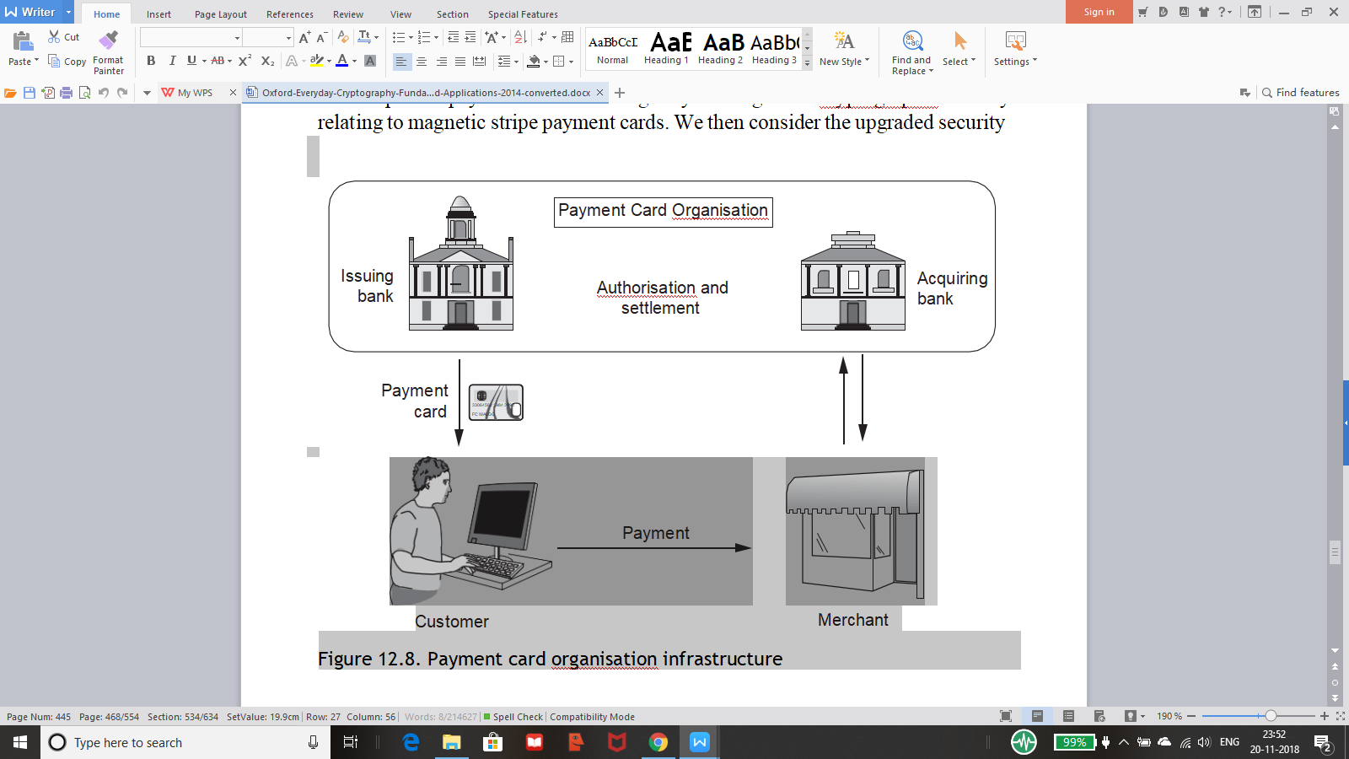

**12.4.2 Magnetic stripe cards**

Most payment cards have magnetic stripes. Even payment cards with chips often retain the magnetic stripe and may resort to using it when they are deployed in environments that do not support EMV. The following description of cryptography used by magnetic stripe cards is based on the practices of Visa and MasterCard.

**PIN PROTECTION**

Consider example of cryptography being used by payment cards concerns online authentication of a user who inserts their magnetic stripe payment card into an ATM. Before releasing any funds, the ATM needs to know whether the user is genuine and whether they are entitled to make the requested withdrawal.

The process begins when the user is asked to enter their PIN into the ATM. The ATM clearly cannot verify this PIN on its own, so it needs to refer the PIN to the user’s issuing bank. Since PINs are sensitive, this information should be encrypted. It is impractical for every ATM to share an encryption key with every issuing bank, so a process of key translation is used:

* The ATM encrypts the PIN and the authentication request message using a key shared by the ATM and the acquiring bank responsible for that ATM (each ATM should have a unique key of this type).
* The acquiring bank decrypts the cipher text and then re-encrypts it under a key known as the acquirer working key, which is a key shared by the acquiring bank and the PCO.
* The PCO decrypts the cipher text and re-encrypts it using an issuer working key, which is a key that the PCO shares with the issuing bank.
* The issuing bank decrypts the cipher text and makes the necessary checks of the PIN and the authentication request message. The response is then relayed back to the ATM.

It would be dangerous simply to encrypt the PIN directly during this process, since the limited number of PINs will result in a limited number of possible cipher texts representing encrypted PINs. If the same key were to be used to encrypt several PINs then an attacker could conduct a dictionary attack that matched a cipher rtext representing an unknown PIN against a ‘dictionary’ of cipher rtexts corresponding to known PINs. This threat is prevented by two important mechanisms:

**Use of a PIN block**. The PIN is never encrypted directly. Instead a *PIN block* is formed, one example of which consists of a 64-bit string containing the PIN being XORed to a 64-bit string containing the *Personal Account Number* (PAN) corresponding to the card. This means that two cards with the same PIN will not be encrypted to the same ciphertext under the same encryption key.

**Session key encryption**. Further security is provided by ensuring that ATMs use session keys, which are generated for a single PIN encryption event and then destroyed.

**CARD VERIFICATION VALUES**

* One major problem with magnetic stripe cards is that they are relatively easy to clone.
* Early payment cards only included routine information such as the PAN and expiry date on the magnetic stripe. Since this information is easily obtained by a potential attacker (most of it is even displayed on the card itself, or can be obtained from receipts), it was very easy for an attacker to forge such a card.
* The problem was alleviated by the inclusion of a cryptographic value known as the *Card Veriﬁcation Value* (CVV) on the magnetic stripe .
* The CVV consists of three digits that are extracted from a hex ciphertext, which is computed by encrypting the routine card information using a key known only to the issuer. The CVV is not displayed on the card and can only be created and veriﬁed by the card issuer.
* The CVV can be obtained by an attacker who has read off all the information contained on the magnetic stripe, for example, a rogue merchant.
* Payment cards thus include a second CVV value, CVV2, which is a cryptographic value computed in a similar (but slightly different) way to the CVV.
* The CVV2 is displayed on the reverse of the payment card, but is not included in the magnetic stripe. The CVV2 is primarily used as a simple check of the physical presence of a card, particularly in transactions made over the telephone or online.

**PIN VERIFICATION VALUE**

* In order to improve availability, PCOs also provide a service which allows PINs to be veriﬁed when the card issuer is unable to process PIN veriﬁcation requests.
* This is conducted using a *PIN Veriﬁcation Value* (PVV), which is computed in a similar way to the CVVs, except that the PIN itself forms part of the plaintext that is encrypted in order to generate the PVV.
* The issuing bank needs to share the key that it uses to compute this PVV with the PCO.
* The PVV is four digits long, so that its security is ‘equivalent’ to that of the PIN itself.
* Like the CVV, the PVV is normally stored on the magnetic stripe but not displayed on the card. During a PIN veriﬁcation request, the PCO recomputes the PVV using the PIN that has been offered by the customer and checks whether this value matches the PVV on the magnetic stripe .If It does then the PIN veriﬁcation is accepted.

**PAYMENT CARD AUTHORISATION**

* When a payment card is inserted into a terminal, the main goal of the terminal is normally to determine the validity of the card and decide whether the transaction that is being requested is likely to go through.
* Prior to magnetic stripe cards, this process required a merchant to make a telephone call to the issuer.
* The ability for a terminal to extract data from the magnetic stripe and automatically contact the issuer in order to authorise a transaction certainly makes this process easier.
* However, it is important to note that with magnetic stripe cards this process still requires direct (online) communication with the card issuer.
* This requirement has restricted the adoption of payment cards of this type in countries with poor communication infrastructures.

**12.4.3 EMV cards**

EMV cards were introduced for two main reasons.

* The first reason was in order to improve the security of payment card transactions.
* The other reason was to lower telecommunication costs by introducing a secure means of authorising a transaction offline, hence reducing the number of times that a merchant might have to contact a card issuer.

**PIN VERIFICATION**

PIN verification becomes much more straightforward for EMV than for magnetic stripe cards, since the PIN can be stored on the chip itself. This allows a terminal to easily verify the PIN without having to contact the card issuer, or use a service based on a PVV.

**OFFLINE DATA AUTHENTICATION**

* In order to authorise an EMV card transaction, a terminal must first decide whether to do an offline check, or whether to conduct a stronger online check that involves communicating with the card issuer.
* The decision as to which check to conduct depends on the transaction amount and the number of transactions conducted since the last online check.
* Offline data authentication does not involve the card issuer. In its most basic form, it provides a means of gaining assurance that the information stored on an EMV card has not been changed since the payment card was created by the card issuer.
* In other words, it provides data origin authentication of the fundamental card data. The stronger mechanisms also provide entity authentication of the card.
* Offline data authentication of a payment card can be conducted directly by a terminal that the card has been inserted into.
* It is impractical to provide this offline service using symmetric cryptography, since each terminal would need to share a symmetric key with every possible issuer.
* The use of key translation, for magnetic stripe PIN verification, requires the issuer to be online.
* Thus public-key cryptography, in the form of a digital signature scheme, is used to provide offline data authentication.
* For space efficiency reasons, EMV cards use a type of RSA digital signature scheme with message recovery to provide this assurance.
* EMV provides three offline data authentication mechanisms:
* **Static Data Authentication (SDA)** is the simplest technique. All that is checked is the digital signature on the card data that is stored on the card. Verification of this digital signature requires access to the issuer’s verification key. Clearly it is not reasonable to expect every terminal to have direct access to every issuer’s verification key. Thus EMV employs a simple certificate hierarchy. In this case the card stores a public-key certificate containing the verification key of the issuer. This certificate is signed by the PCO, and the PCO’s verification key is installed in every terminal supporting EMV.
* **Dynamic Data Authentication (DDA**) goes one step further and provides this assurance in a dynamic way that differs for each transaction, hence providing another layer of security against card counterfeiting. During DDA, a challenge– response protocol is run that provides entity authentication of the card. In this case each card has its own RSA key pair and includes a public-key certificate for the card’s verification key, signed by the issuer, as well as the issuer’s public-key certificate, signed by the PCO. We thus have a three-level public-key certificate chain. The card computes a digital signature on the card data as well as some information unique to the current authentication session. The terminal uses the certificates offered by the card to verify this digital signature.
* **Combined Data Authentication (CDA)** is similar to DDA, except that the card also signs the transaction data, thus providing assurance that the card and terminal have the same view of the transaction. This protects against man-in-the-middle attacks that seek to modify the transaction data communicated between card and terminal. In contrast, DDA can take place before the transaction details have been established.

**ONLINE AUTHENTICATION**

Online authentication is the stronger check, which requires communication with the card issuer. As with DDA, the objective of online card authentication is for a terminal to gain entity authentication assurance of a payment card that is involved in a transaction. This is provided by means of a simple challenge– response protocol, based on a symmetric key that is shared by the card issuer and the payment card, which stores it on the chip. The only complication is that the terminal does not share this key, hence the issuer must be contacted online in order to verify the response. More specifically:

1. The terminal generates transaction data (which includes the payment card details) and a randomly generated challenge, which it then sends to the card.

2. The card computes a MAC on this data with the key that it shares with the issuer. This MAC is called the authorisation request cryptogram, and is passed on to the issuer.

3. The issuer computes its own version of the authorisation request cryptogram and compares it with the value received from the card. The issuer is also able to conduct a check that there are sufficient funds in the account to proceed with the transaction.

**TRANSACTION CERTIFICATES**

At the end of each transaction a transaction certificate (TC) is generated. This is a MAC computed on the details and outcome of the transaction and is passed back to the card issuer. The TC is computed using the key shared by the card and the card issuer. The TC is normally only required as evidence in the event of a subsequent dispute about certain aspects of the transaction.

**SECURITY OF MANAGEMENT FUNCTIONS**

A number of important management functions concerning security features of the payment card can be remotely managed by sending instructions to the card.

These include PIN changes, PIN unblocking instructions and changes to card data items (such as credit limits). These instructions are sent by the card issuer to the card (via a terminal). They are authorised by computing and verifying a MAC on the instruction, which is generated using a symmetric key that is shared by the card issuer and the card. Since this is a very different use of symmetric cryptography, in line with the principle of key separation this key is different from the one used in online authentication.

**12.4.4 Using EMV cards online**

* An increasing number of transactions are conducted when the card is remote from the merchant, most commonly when a customer makes an online transaction. These are referred to as card-not-present (CNP) transactions.
* The potential for fraud in such transactions is high, since the most common information used to authenticate CNP transactions is simple card data (PAN, expiry date, CCV2), which is relatively easily acquired by a determined attacker.
* From the card holder perspective, the counter to this fraud threat has been the ability to challenge fraudulent transactions. However, this brings significant costs to the merchants, as well as being an inconvenience to the PCOs and cardholders when new cards have to be reissued to customers who have been fraud victims.
* Secure Electronic Transactions (SET) was a standard that proposed a heavy architecture and set of procedures for securing CNP transactions. It relied on an overarching public-key management system and required all merchants to acquire special supporting equipment. Its complexity prevented it from being successful and so Visa and Mastercard developed a more lightweight approach known as 3DSecure.
* The two main goals of 3DSecure are:

1. The card issuer is able to authenticate its payment card holders during a CNP transaction.
2. A merchant gains assurance that it will not later be financially punished because of a fraudulent transaction.

3DSecure relies on the following process:

1. A merchant that is 3DSecure-enabled puts in a request for authorisation of the card.
2. The card issuer contacts the card holder and requests authentication information. While EMV-CAP provides a natural way to enable this, a common instantiation is for the card issuer and card holder to have preagreed a password, which the card holder must enter into a form presented to them in an embedded frame on their browser.
3. 3. If authentication is successful, the card issuer computes a MAC on the critical transaction data, using a symmetric key known only to them. This MAC is known as a Cardholder Authentication Verification Value (CAVV) and acts as sort of ‘signature’, vouching for the authentication of the card holder and the transaction data. The CAVV will be used to resolve any subsequent disputes about the transaction.

**12.4.5 Using EMV cards for authentication**

Since EMV cards have cryptographic capability, and EMV-supporting bank customers have such a card by default, it is natural to consider using the EMV card as part of an entity authentication mechanism. This is precisely the thinking behind the Chip Authentication Program (CAP), which specifies a range of entity authentication options (EMV-CAP explicitly refers to MasterCard technology, while Visa have a similar scheme known as Dynamic Passcode Authentication). These are supported by a CAP reader, which is a handheld device with a display and keypad. The customer authenticates directly to the CAP reader by means of a PIN. The CAP reader can then support several different entity authentication mechanisms:

* **Identify.** This option displays a number on the CAP reader that is computed from a symmetric key on the EMV card and an EMV customer transaction counter, which is also stored and updated on the card. This mechanism is a type of sequence-number-based dynamic password scheme. The cryptographic computation essentially involves computing a CBC-MAC on the input.
* **Response.** In this case the bank provides the customer with a randomly generated challenge. The customer types the challenge into the CAP reader, which computes a response using the symmetric key on the EMV card (again, based on CBC-MAC). Finally, the customer provides the bank with the displayed response.
* **Sign.** This is stronger version of the response mechanism, which involves the CBC-MAC being computed on basic transaction data (amount and recipient account) as well as the challenge value. This can be used to provide a type of ‘digital signature’ on the transaction. This is an example of the ‘asymmetric trust relationship’ use of MACs to provide non-repudiation.

**12.4.6 Payment card key management**

**KEY MANAGEMENT SYSTEM**

While the cryptography used by magnetic stripe cards is entirely symmetric, EMV uses a hybrid of symmetric and public-key cryptography. While PCOs allow issuing and acquiring banks to manage the keys of their own customers, the PCOs provide overarching key management services that link up these banks and facilitate secure transactions. The model depicted in Figure 12.8 that underlies payment card transactions is essentially the same as the connected certification model.. It is thus a good model to adopt given the distributed nature of a PCO’s network of banks.

**KEY GENERATION**

A PCO generates its own master public-key pair. PCOs maintain master RSA key pairs of different lengths in order to cope with potential improvements in factorisation techniques. Individual banks are responsible for the genealso maintained on the card and is communicated to relying parties during a transaction.

**KEY ESTABLISHMENT**

The advantage of a closed system of this type is that the keys stored on a card can be pre-installed during the manufacturing (or personalisation) process. This is slightly more complex for RSA key pairs, since they cannot be mass generated as efficiently as symmetric keys. The session keys used in individual transactions are established on the fly during the transaction, as just discussed. A PCO’s verification key is installed into terminals during their manufacture. PCOs also oversee an important symmetric key hierarchy. At the top level are zone control master keys, which are manually established using component form. These are used to establish the acquirer working keys and issuer working keys.

**KEY STORAGE**

All the long-term secret or private keys used in EMV payment card systems are protected in tamper-resistant hardware, either in the form of an issuer’s hardware security module or the chip on the payment card.

**KEY USAGE**

In general, key separation is enforced in EMV. The two main security functions that involve encryption using keys stored on a card are conducted using separate symmetric keys.

**12.4.8 Payment card cryptographic design issues**

The main cryptographic design issues concerning payment card cryptographic security mechanisms are:

**Use of well-respected cryptographic algorithms.** Payment cards use 2TDES and RSA, which are well-established algorithms.

**Targeted use of public-key cryptography**. Payment cards uses public-key cryptography precisely when it delivers substantial benefits, namely in simplified key management for the support of offline data authentication.

**Balance of control and flexibility**. PCOs strictly control the part of the key management infrastructure that they need to, but otherwise devolve control to participating banks. This provides scalable key management and allows banks to develop their own relationships with their customers.

**Efficient use of related data.** Payment cards use data in a number of imaginative ways. For example, PANs are used to derive keys, and items of transaction data are used as challenges in authentication protocols. This is both efficient and clever.

**12.5 Cryptography for video broadcasting**

**12.5.1 Video broadcasting background**

Commercial television broadcasters have traditionally financed the provision of their services either through government subsidy or advertising revenue. This is primarily because most analogue broadcast content can be received by anyone with access to a suitable device, such as a television set. This makes alternative business models, such as those based on annual subscription, hard to enforce.

An alternative option is to ‘encrypt’ analogue content using special techniques that are developed for particular broadcast technologies. This process is often referred to asscrambling. This requires a consumer of content to acquire dedicated hardware in order to use decryption to recover the content. This requirement thus presents an opportunity for revenue collection. Digital video broadcast networks process digital content, thus making it possible to use the full range of modern cryptographic mechanisms to protect content. This, in turn, enables a wide variety of different business models. Most of these require consumers to obtain specific hardware (or occasionally software) in order to recover content. Common models include full subscription services that allow consumers to access all broadcast content for a specific period of time, package subscription services that allow consumers to access ‘bundles’ of predefined broadcast content, and pay-per-view services that allow the purchase of specific broadcast content (for example, a live broadcast of a sports event). The compression of digital video broadcasts also allows more content to be broadcast than that of analogue over a similar bandwidth. It thus creates the opportunity for a much more diverse provision environment.

* Figure 12.9 shows a simple example of a possible infrastructure for a digital video broadcast network.
* The broadcast source transmits the broadcast content, and is under the control of the broadcast provider. The broadcast content is transmitted to the consumer of the content, who requires access to a suitable broadcast receiver in order to receive the signal.
* In the example in Figure 12.9, the communication channel is over the air via a satellite link, hence the broadcast receiver takes the form of a satellite dish.
* However, a digital video broadcast could just as well be transmitted by other media, such as a fibre optic cable, in which case the broadcast receiver is any hardware device capable of receiving the content.
* As well as receiving the data transmitted by the broadcast source, the consumer requires a content access device, which has the capability of decrypting to recover the broadcast content. While this can be implemented in software, most content access devices are hardware devices that contain a smart card.
* The critical data that is required to control access to the broadcast content, such as cryptographic keys, will normally be stored on the smart card, thus allowing the potential for a content access device to be used to obtain content from different broadcast providers.
* In such cases choose to regard the ‘content access device’ as the hardware and the smart card, unless otherwise specified.

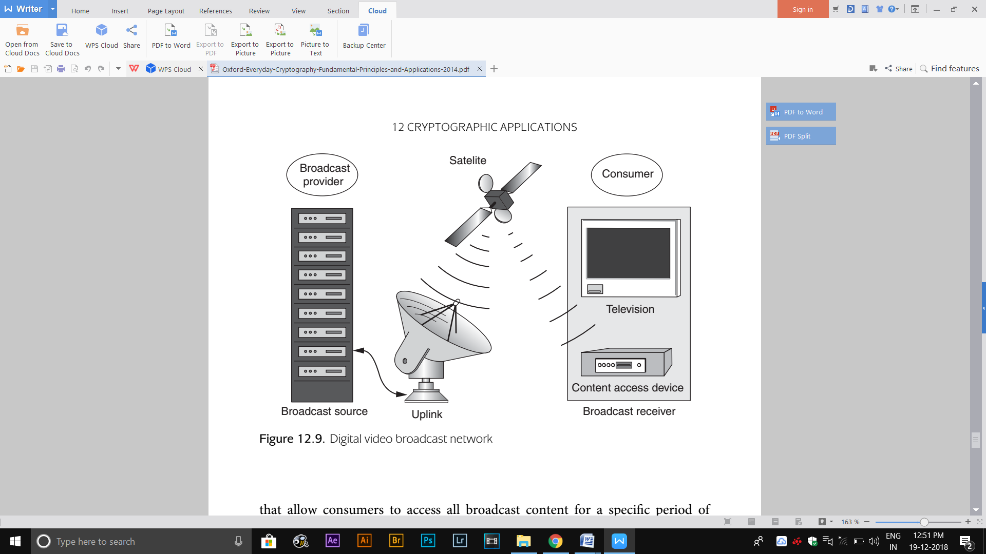

**12.5.2 Video broadcasting security requirements**

Two important constraints on the broadcast network environment:

**One-way channel.** The broadcast communication channel only operates in one direction: from broadcast source to broadcast receiver. There is no means by which a consumer can send information back to the broadcast source on this communication channel.

**Uncontrolled access**. Just as for analogue broadcasts, digital video broadcast content can be received by anyone with the right broadcast receiver technology (a satellite dish in our example in Figure 12.9).

The security requirement for digital video broadcast is thus, simply:

**Confidentiality of the broadcast content**. In order to control the revenue stream the broadcast provider must make the broadcast content essentially ‘worthless’ to anyone who has not purchased the necessary content access device. In other words, confidentiality is required on the broadcast channel, with only authorised consumers having access to the necessary decryption keys.

**Entity authentication.** Most of our previous applications required some level of entity authentication, which would be one way of controlling which consumers get access to broadcast video content. However, this requires the consumer to be able to communicate with the broadcast source, which in this case is not possible. Entity authentication of the broadcast source is possible, but unnecessary, since the threat of an attacker posing as a broadcast source and sending false video broadcasts is not particularly relevant to most commercial broadcast environments.

**Data integrity.** A video broadcast channel is potentially prone to errors in the transmission channel. However, the threat against data integrity is more likely to be accidental errors rather than deliberate ones introduced by a malicious attacker. Hence the solutions lie in the area of error-correcting codes and not cryptographic mechanisms.

**12.5.3 Cryptography used in video broadcasting**

The cryptographic design decisions for GSM encryption namely:

**A fully symmetric cryptographic architecture.** Video broadcast networks are closed systems.

**Stream ciphers for data encryption**. Video broadcasts involve streaming data in real time over potentially noisy communication channels.

**Fixing the encryption algorithm**. Agreeing on use of a fixed encryption algorithm allows this algorithm to be implemented in all broadcast receivers, aiding interoperability.

**Proprietary encryption algorithm.** Choosing to design a proprietary encryption algorithm was justifiable for the same reasons as for GSM. In this case the expertise lay with members of the Digital Video Group (DVB), which is a consortium of broadcasters, manufacturers, network operators, software developers, and regulatory bodies with interests in digital video broadcasting. As for GSM, one of the influences behind the design was to make decryption as efficient as possible, since content access devices are less powerful than broadcast sources.

The proprietary encryption algorithm that was designed was CSA. While CSA was standardised by ETSI. The CSA was implemented in a software application and subsequently reverse-engineered. The CSA is essentially a double stream cipher encryption. The first encryption is based on a proprietary block cipher deployed in CBC mode, which means that it operates as a stream cipher . The second layer of encryption uses a dedicated stream cipher to encrypt the ciphertext produced during the first encryption (this is a slight simplification). The key length is 64 (only 48 of the bits are actually used for encryption) and the same encryption key is used for both encryption processes.

**12.5.4 Key management for video broadcasting**

The primary key management task for digital video broadcasting is simple to state: the keys required to recover broadcast content should be available only to those consumers who are authorised to view the broadcast content. However, there are several complications:

**The number of potential consumers.** A digital video broadcast network is likely to have a large number of consumers (in some cases this could be several million), hence the key management system design must be sufficiently scalable that it works in practice.

**Dynamic groups of authorised consumers.** The groups of consumers who are authorised to view digital broadcast content is extremely dynamic. Payper-view services provide the extreme example of this, where the group of authorised consumers is likely to be different for every content broadcast.

**Constant service provision.** In many applications a broadcast source will be constantly streaming digital video content that needs to be protected. There are no break periods in which key management operations could be conducted. Most key management must therefore be conducted on the fly.

**Precision of synchronisation.** Stream ciphers require the keys at each end of the communication channel to be synchronised. In digital video broadcasting this synchronisation has to happen between the broadcast source and all (and as we have just pointed out, this could be ‘millions of ’) authorised consumers. This synchronisation must be close to being perfect, otherwise some consumers may incur a temporary loss of service.

**Instant access.** Consumers normally want instant access to broadcast content and will not tolerate delays imposed by key management tasks.

**VIDEO BROADCAST KEY MANAGEMENT SYSTEM DESIGN**

* All video broadcast content must be encrypted during transmission. A symmetric key, which will be refer to as the content encryption key (CEK). Since the broadcast source only transmits one version of an item of broadcast content, the content encryption key used to encrypt a specific item of content must be the same for all consumers.
* Since consumers have different access rights to digital content, the CEK for two different items of broadcast content must be different.
* The challenge is thus to make sure that only consumers who are authorised to access content can obtain the appropriate CEK.

The following key management design decisions:

* **Encrypted CEK is transmitted in the broadcast signal.** The CEK is transmitted along with the content itself and is made ‘instantly available’ by being continuously repeated, perhaps every 100 milliseconds or so. Clearly the CEK cannot be transmitted in the clear, otherwise anyone receiving the broadcast signal could obtain it and hence recover the content. Thus the CEK is transmitted in encrypted form. We will refer to the key used to encrypt the CEK as the key encrypting key (KEK).
* **CEK is frequently changed.** Once someone has access to the CEK, they can use it to recover all broadcast content that is encrypted using it. Thus it is important to frequently change the CEK. In most video broadcast systems the CEK typically changes every 30 seconds, but this can happen as often as every five seconds.
* **CEK is transmitted in advance.** In order to aid synchronisation and instant access, the CEK is issued in advance of the transmission of any content broadcast using it. Clearly this cannot be too far in advance because of the dynamic nature of the authorised consumer base. The compromise is to constantly transmit two (encrypted) CEKs, which consist of:

1. the current CEK that is being used to encrypt the current broadcast content;

2. the ‘next’ CEK that will be used to encrypt the next broadcast content. Hence the content access device has time to recover the next CEK and have it instantly available as soon as the CEK is changed.

* **Use of symmetric key hierarchies**. Video broadcast schemes uses KEKs to encrypt the CEKs. This of course just ‘transfers’ the access problem to making sure that only authorised consumers have access to the required KEKs.

**VIDEO BROADCAST KEY ESTABLISHMENT**

* A video broadcast scheme establishes the KEKs that are necessary for authorised consumers to obtain the CEKs that they are entitled to.
* A video broadcast schemes use symmetric key hierarchies. At the ‘top’ of each these hierarchies are keys that are shared only by the broadcast provider and a particular consumer, which we refer to as consumer keys (CKs).
* In a simple system, with relatively few consumers, these CKs could be used to encrypt the KEKs. However, there are two reasons why this is not very practical:

1. Most video broadcast systems have so many consumers that sending an encrypted KEK in this way would require too much bandwidth, since a unique ciphertext would have to be sent for each consumer.

2. Each KEK itself must be frequently changed, for similar reasons to the CEKs. This might happen, say, on a daily basis. Thus the bandwidth problems are further exacerbated by the need to frequently update the KEKs.

* The compromise is to deploy zone keys (ZKs), which are keys shared by groups of consumers. Zone keys have longer lifetimes than KEKs, but shorter lifetimes than CKs.
* A relevant ZK is initially sent to a consumer encrypted using their CK. The consumer then uses the ZK to recover KEKs, which are used to recover CEKs.
* When a ZK needs to be changed, the new ZK does need to be sent to every consumer who requires it, but this event occurs much less frequently than for KEKs (which in turn occurs much less frequently than for CEKs).
* The consumer keys, which sit at the top of these key hierarchies, are stored on the smart cards of the content access devices. They are thus established prior to the issuing of the smart cards to the consumers.
* A simple example set of key hierarchies is shown in Figure 12.10. In this example there are are five consumers, divided into two zones. In practice, multiple layers of zone keys can be deployed in order to enhance scalability.

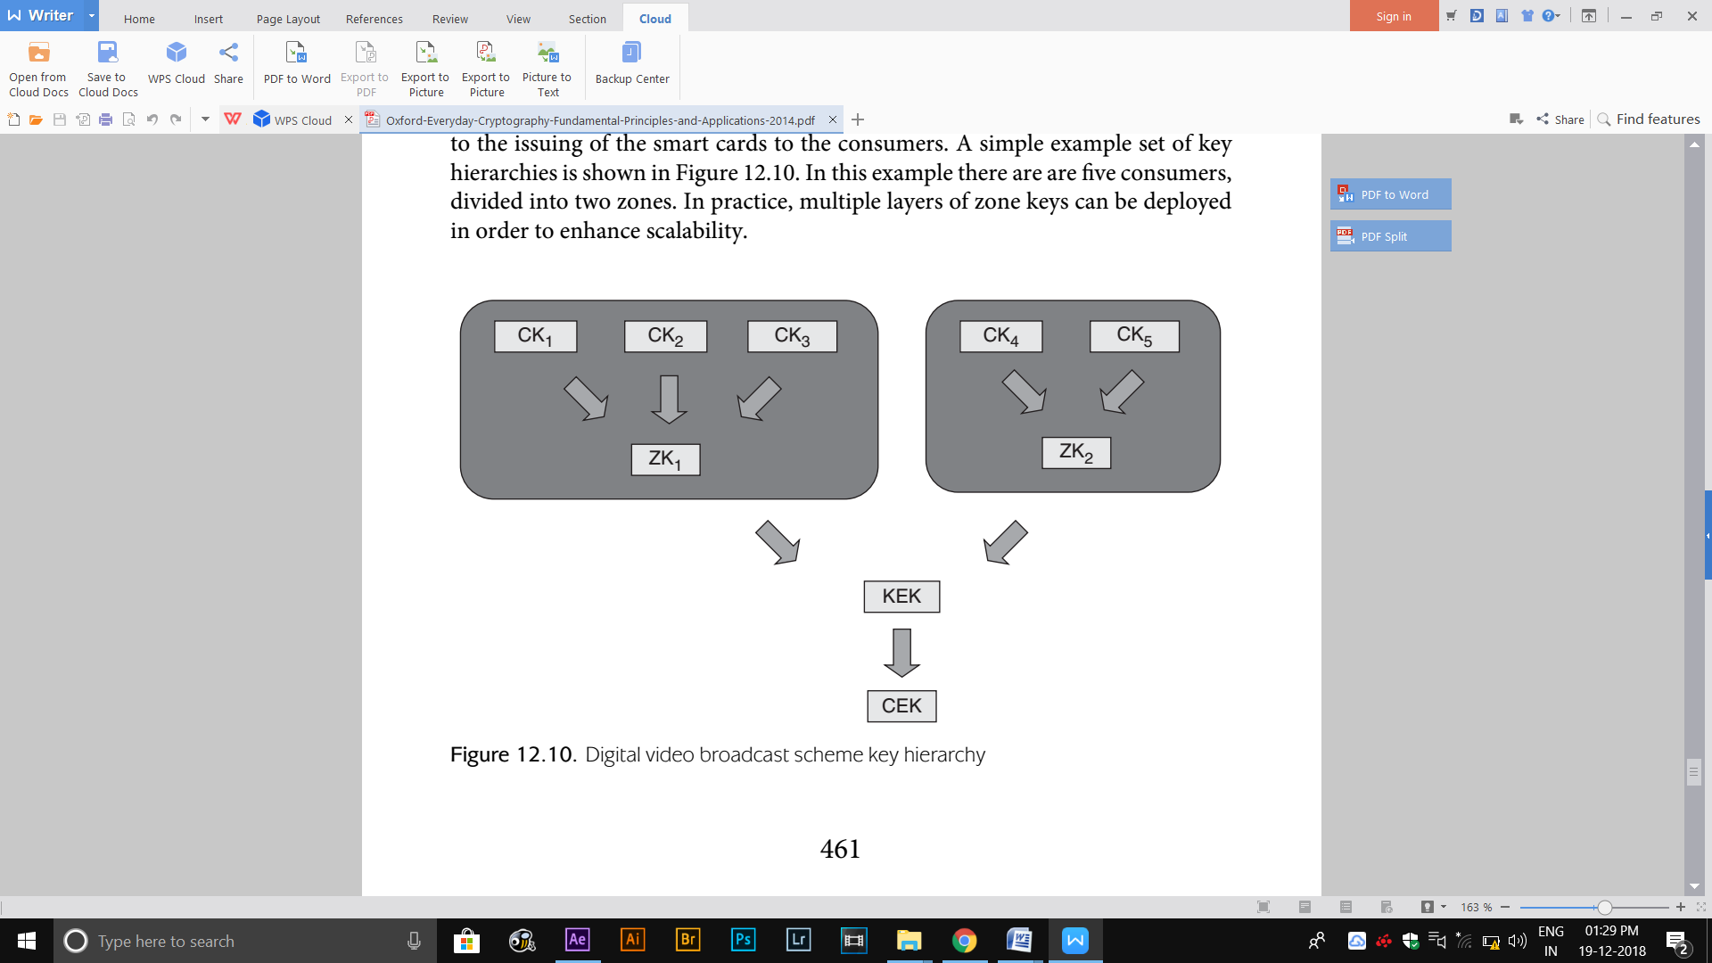

**12.5.6 Video broadcast design issues**

**Use of symmetric cryptography.** The closed nature of a video broadcast scheme facilitates the use of a fully symmetric cryptosystem.

**Use of a symmetric key hierarchy.** Video broadcast schemes provide a good example of the benefits of deploying a key hierarchy to support symmetric key management.

**The influence of operational constraints.** While the security requirements for video broadcast networks are fairly straightforward, the operational constraints require some innovative key management controls.

**Partially standardised infrastructure**. Video broadcast schemes follow some common standards, for example, for content encryption, while leaving other aspects such as higher-level key establishment open to custom design by individual broadcast providers. While this provides the opportunity for a diverse market of interoperable schemes, it also presents a potential source of vulnerability in specific systems.

**12.6 Cryptography for identity cards**

**12.6.1 eID background**

Within a specific context, such as a workplace, most people accept cards that contain and/or display data relating to the identity of the holder. However, the attitude towards national identity card schemes is surprisingly diverse and, to an extent, cultural. In some countries, such as the UK, there is a great deal of hostility to such schemes. This is largely due to concerns over privacy issues, costs of deployment, data management and doubts about the utility of such a scheme. In many other countries, such as Belgium, national identity card schemes have been rolled out and are integrated into daily life.

The main application of national identity cards is to present independently issued evidence of the identity of the card holder. Such cards typically display a photograph of the card holder and some personal details, which may include a handwritten signature. However, the progress in smart card technology and the development of cryptographic applications has presented the opportunity for national identity cards to provide additional functionality and thus, perhaps, become more useful.

* The eID card scheme was motivated by the establishment of the 1999 European Directive on Electronic Signatures, which created a framework that enabled electronic signatures to become legally binding.
* The first eID cards were issued to Belgian citizens in 2003 and from 2005 all newly issued identity cards were eID cards.
* The eID card has four core functions:

**Visual identification.** This allows the card holder to be visually identified by displaying a photograph on the card alongside a handwritten signature and basic information such as date of birth (see Figure 12.11). This functionality is also provided by previous Belgian identity cards.

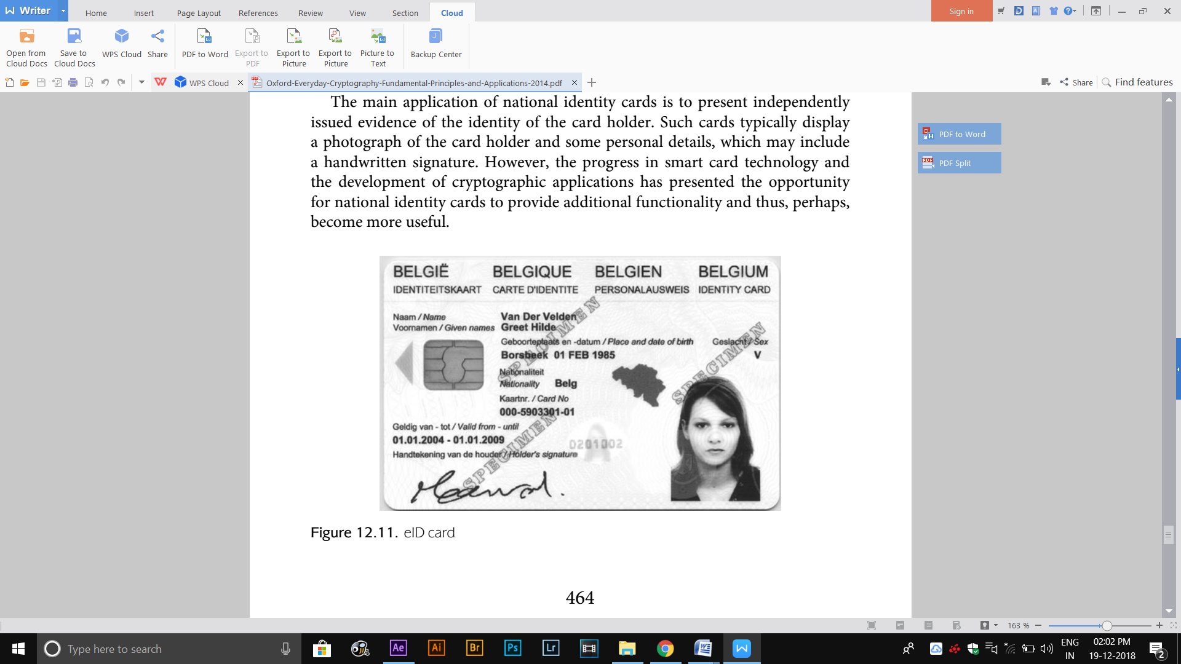

**Digital data presentation.** This allows the data on the eID card to be presented in electronic form to a verifying party. The card data has a specific format and includes:

• a digital photograph of the card holder;

• an identity file which consists of:

* personal data such as name, national identity number, date of birth, and special status (for example, whether the card holder has a disability);
* a hash of the digital photograph of the card holder;
* card-specific data such as chip number, card number and validity period;

• an address file which consists of the card holder’s registered address.

Applications of digital data presentation include access control to facilities such as libraries, hotel rooms and sports halls.

**Digital card holder authentication**. This allows a card holder to use the eID card to ‘prove’ their identity in real time to a verifying party. In other words, it facilitates entity authentication of the card holder. The many listed applications of digital card holder authentication include remote access to various internet services, including official document requests (for example, birth certificates), access to an online tax declaration application, and access to patient record information.

**Digital signature creation**. This allows the card holder to use the eID card to digitally sign some data. Applications of digital signature creation include signing of electronic contracts and social security declarations. Digital signatures created using an eID card are legally recognised.

**12.6.2 eID security requirements**

**Data origin authentication of the card data**. In order to provide digital data presentation, assurance that the card data has not been changed since the card was issued must be provided.

**Ability to provide a data origin authentication service.** In order to support digital card holder authentication, it is necessary for an eID card to be used as part of an entity authentication service. The eID card’s role in this is to provide a data origin authentication service, which can then be used to support an entity authentication protocol between the card holder and a verifying party.

**Ability to provide a non-repudiation service.** In order to support digital signature creation, an eID card must be able to provide non-repudiation.

**12.6.3 Cryptography used in eID cards**

The cryptography in the eID card is relatively straightforward. The following design issues are important in determining the eID card’s cryptographic capability:

**Use of public-key cryptography**. The open nature of the potential application space for eID cards dictates that public-key cryptography must be supported. It is impractical for an eID card to contain pre-loaded symmetric keys that will be ‘meaningful’ to all unknown future applications.

**A digital signature scheme suffices**. All three of the security requirements for eID cards can be met by using a digital signature scheme. The first requirement does not even require the digital signature scheme to be implemented on the eID card, however, the second and third requirements do need this. Note that the eID card is not required to have the capability to encrypt or decrypt data.

**Use of a publicly known digital signature scheme**. In order to encourage use of the eID card and aid interoperability, it is imperative that the digital signature scheme that is deployed is widely respected and supported.

**12.6.4 Provision of the eID card core functions**

The eID card scheme is governed by an entity called the National Register (NR). The NR can be considered as a trusted third party that facilitates the scheme. The NR is responsible for issuing eID cards and hence also takes ‘ownership’ of the personal data contained on them.

Each eID card contains two signature key pairs and one additional signature key:

**Authentication key pair.** This key pair is used to support digital card holder authentication.

**Non-repudiation key pair.** This key pair is used to support digital signature creation.

**Card signature key.** This signature key can be used to authenticate the card, rather than the card holder. Only the NR knows the verification key that corresponds to a particular eID card. This signature key is only used for administrative operations between the card and the NR.

**DIGITAL DATA PRESENTATION**

This involves a verifying party reading the card data and then gaining assurance that the data on the card is correct. To gain this assurance, the verifying party needs to verify two digital signatures that are created by the NR and stored on the eID card:

**Signed identity file.** This is a digital signature generated by the NR on the identity file.

**Signed identity and address file.** This is a digital signature generated by the NR on a concatenation of the signed identity file and the address file. In other words, this takes the form:

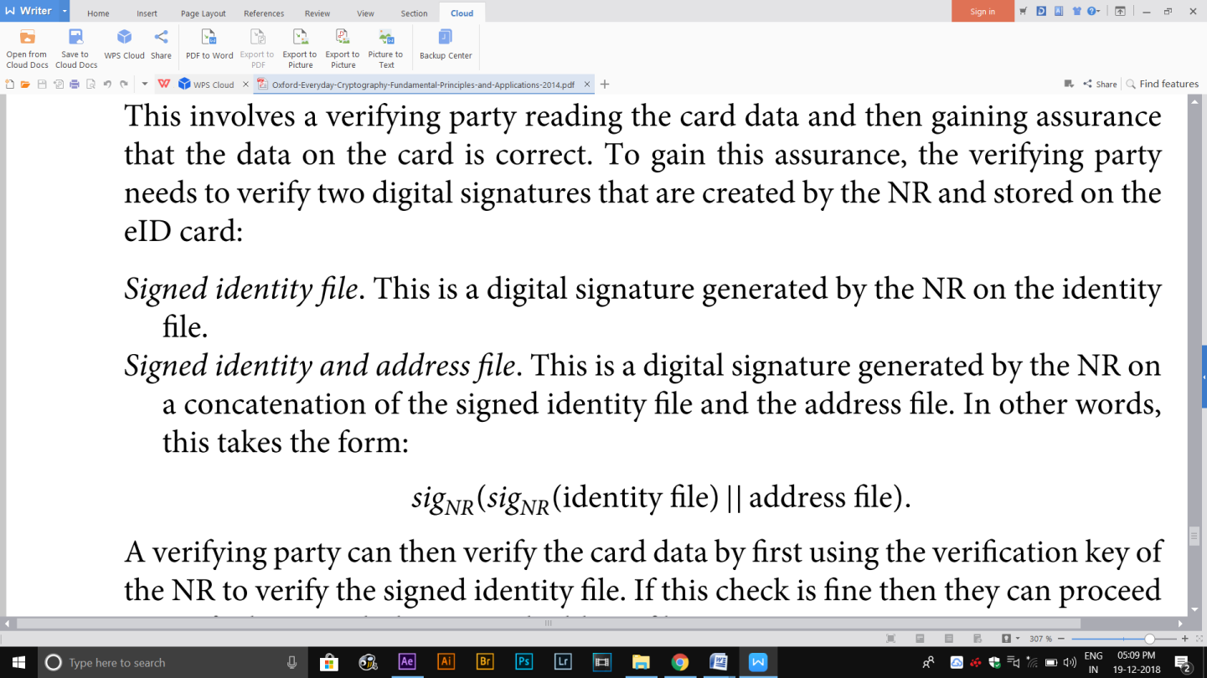

* A verifying party can then verify the card data by first using the verification key of the NR to verify the signed identity file. If this check is fine then they can proceed to verify the signed identity and address file.
* The reason that the NR does not simply sign all the card data is that address changes are much more frequent than changes to the content of the identity file. Thus the NR can update an address on the card without having to reissue a new eID card.

**DIGITAL CARD HOLDER AUTHENTICATION**

Each eID card holder can activate the signature keys on the eID card through the use of a PIN. The card holder also requires access to an eID card reader, which may include a PIN pad. This provides an interface between the eID card and the card holder’s computer. A typical card holder authentication process is illustrated in Figure 12.12. In this example, a visited web server is requesting authentication of the card holder:

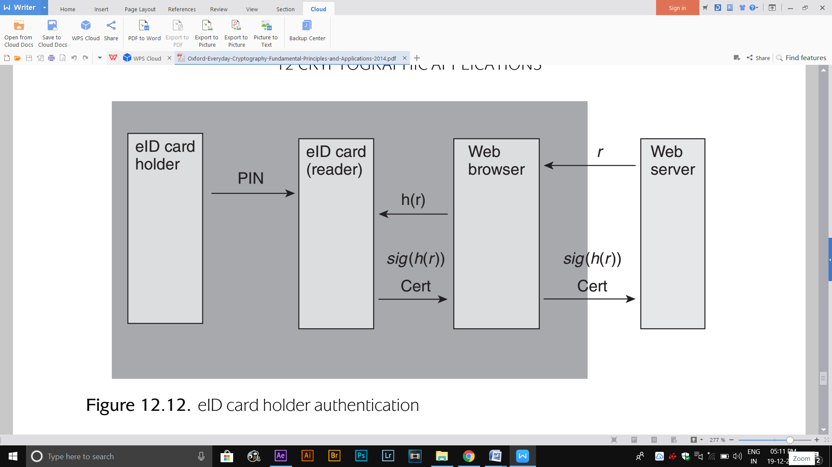

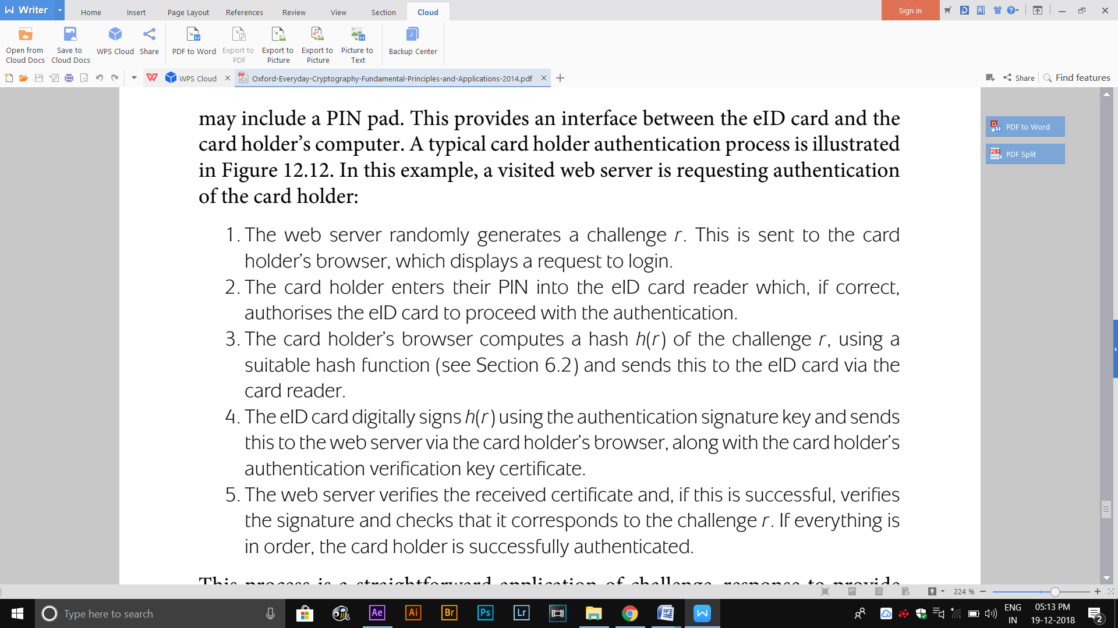

**12.6.5 eID key management**

eID CERTIFICATES The eID card scheme key management is based on the closed certification model. It uses a certification hierarchy, in order to provide a scalable approach to certificate issuing. This certification hierarchy is indicated in Figure 12.13. The main CAs involved are:

**Belgium Root CA**. This CA is the root CA that oversees all the eID scheme certification. It possesses a 2048-bit RSA verification key certificate that is both self-signed and signed by a commercial CA.

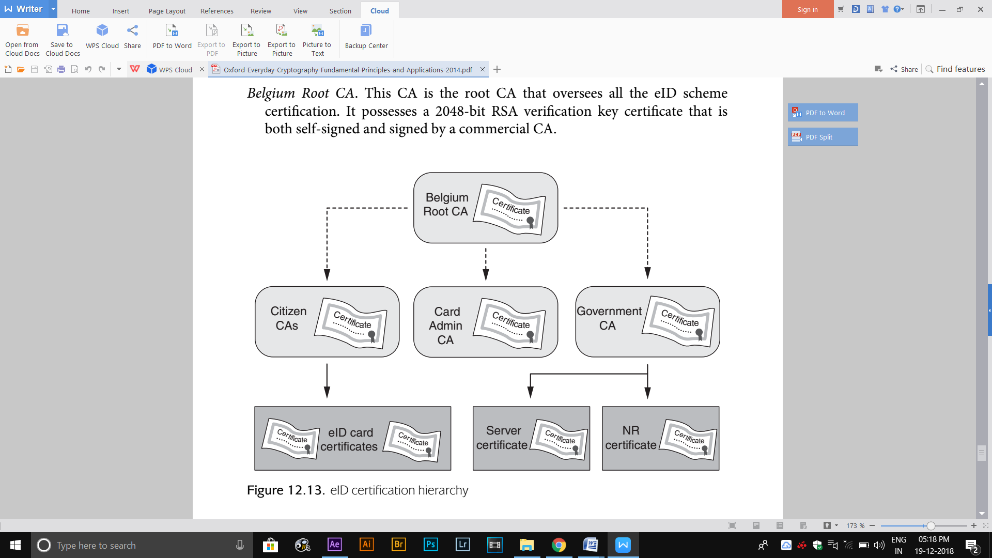

**Citizen CAs.** These CAs issue certificates to card holders and are responsible for signing the eID card authentication and non-repudiation verification key certificates. Citizen CAs have a 2048-bit RSA verification key signed by the Belgium Root CA.

**Card Admin CA.** This CA issues certificates to organisations carrying out administrative operation of the eID card scheme, such as those managing address changes and key pair generation. The Card Admin CA has a 2048-bit RSA verification key signed by the Belgium Root CA.

**Government CA.** This CA issues certificates to government organisations and web servers, including the NR. The Government CA has a 2048-bit RSA verification key signed by the Belgium Root CA.

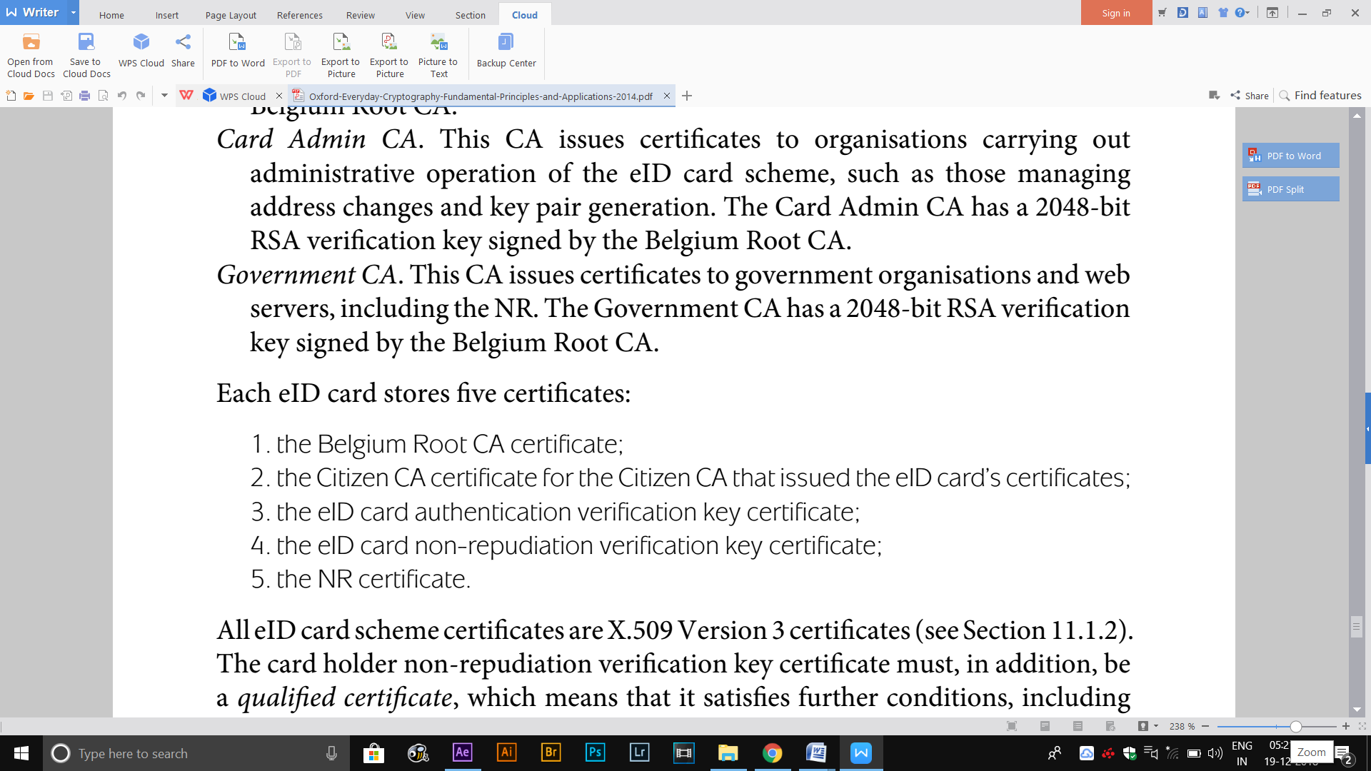

**eID CARD ISSUING PROCESS**

The process of issuing an eID card is quite complex and involves several different organisations. It serves as a good illustration of the intricacies of generating public- key certiﬁcates,. The process is indicated in Figure12.14 and consists of the following steps:

1. Either after requesting, or being invited to apply for, an eID card, the eID applicant attends a local government office. This office essentially acts as the RA. The applicant presents a photograph to the RA, which then verifies the personal details of the applicant and formally signs an eID card request.
2. The eID card request is sent from the local government office to the *card* personaliser(CP), and the NR is notified. The CP checks the eID card request. For simplicity we will assume the existence of a single CP, who is responsible for creating the physical aspects of the card and for inputting the relevant data onto the chip on the card.
3. The CP creates a new eID card and generates the required key pairs on the card itself. The CP then sends are quest for certificates to the relevant Citizen CA via the NR, who issues a certificate serial number for each certificate.
4. The Citizen CA generates certificates and sends them to the CP, who stores the month ecard. The CA then immediately suspends these certificates.
5. The CP writes all the remaining card data onto the card and then deactivates the card.
6. The CP sends:
   * The first part of an activation code *AC*1 to the NR;
   * These cond part of the activation code *AC*2 and a PIN to the applicant;
   * The inactive eID card to the RA.
7. The applicant revisits the RA and presents *AC*2. This is then combined with *AC*1, which the RA requests from the database of the NR.
8. The CA activates the suspended card certificates and the active eID card is issued to the applicant.

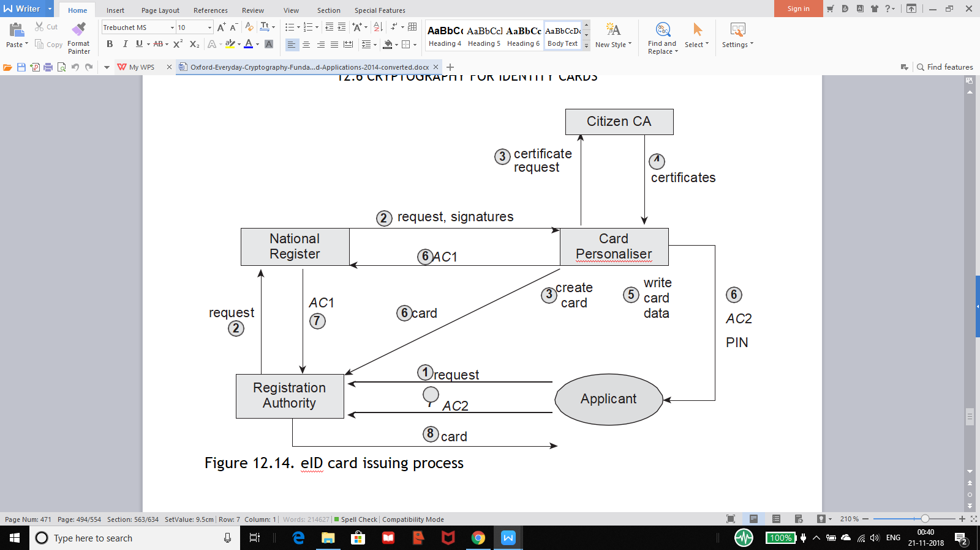

**eID CERTIFICATE REVOCATION**

There are two special situations in which an eID card certificate has the status of being revoked:

1. the eID card non-repudiation verification key certificate is revoked for juveniles under the age of 18;

2. the eID card authentication verification key certificate is revoked for children under the age of 6.

* The main technique used to manage certificate revocation in the eID card scheme is CRLs .
* A significant problem of the eID card scheme is that the potential size of CRLs is considerable.
* The eID card scheme Citizen CAs issue new base CRLs every three hours. During the period between updates of the base CRL, much smaller delta CRLs are issued, which identify changes to the last base CRL.
* In this way anyone who wishes to maintain their own local copy of the complete CRLs for the eID card scheme does not have to regularly download the full database.
* All CRLs are digitally signed by the issuing Citizen CA using 2048-bit RSA.

**eID SIGNATURE VALIDITY**

the potential validity of digital signatures during two specific periods of time:

**Digital signatures created after an incident but before revocation.** A potential problem arises if a relying party verifies an eID card signature in the period between occurrence of a security incident (of a type that invalidates the eID card non-repudiation verification key certificate) and the revocation of that certificate. If the time of the incident can be precisely verified then, technically speaking, a digital signature created during this period is unlikely to be valid. Applications need to be aware of this potential problem and have procedures for coping with it. The Citizen CAs assist this process by frequently issuing base and delta CRLs.

**Validity of digital signatures after expiry or revocation of the eID card (nonrepudiation verification key certificate).** So long as a digital signature is verified before expiry or revocation of the eID card (or its non-repudiation verification key certificate) then it should still be regarded as valid (and, indeed, may be legally binding) after the expiry or revocation date. One method for making this more explicit is for the signer who signs some data to obtain a digital signature from a trusted third party that attests to the validity of that signature at a specific point in time. Namely, the signer Alice presents her digital signature sigA(data) to the TTP, who verifies this signature at time t and then generates the digital signature:

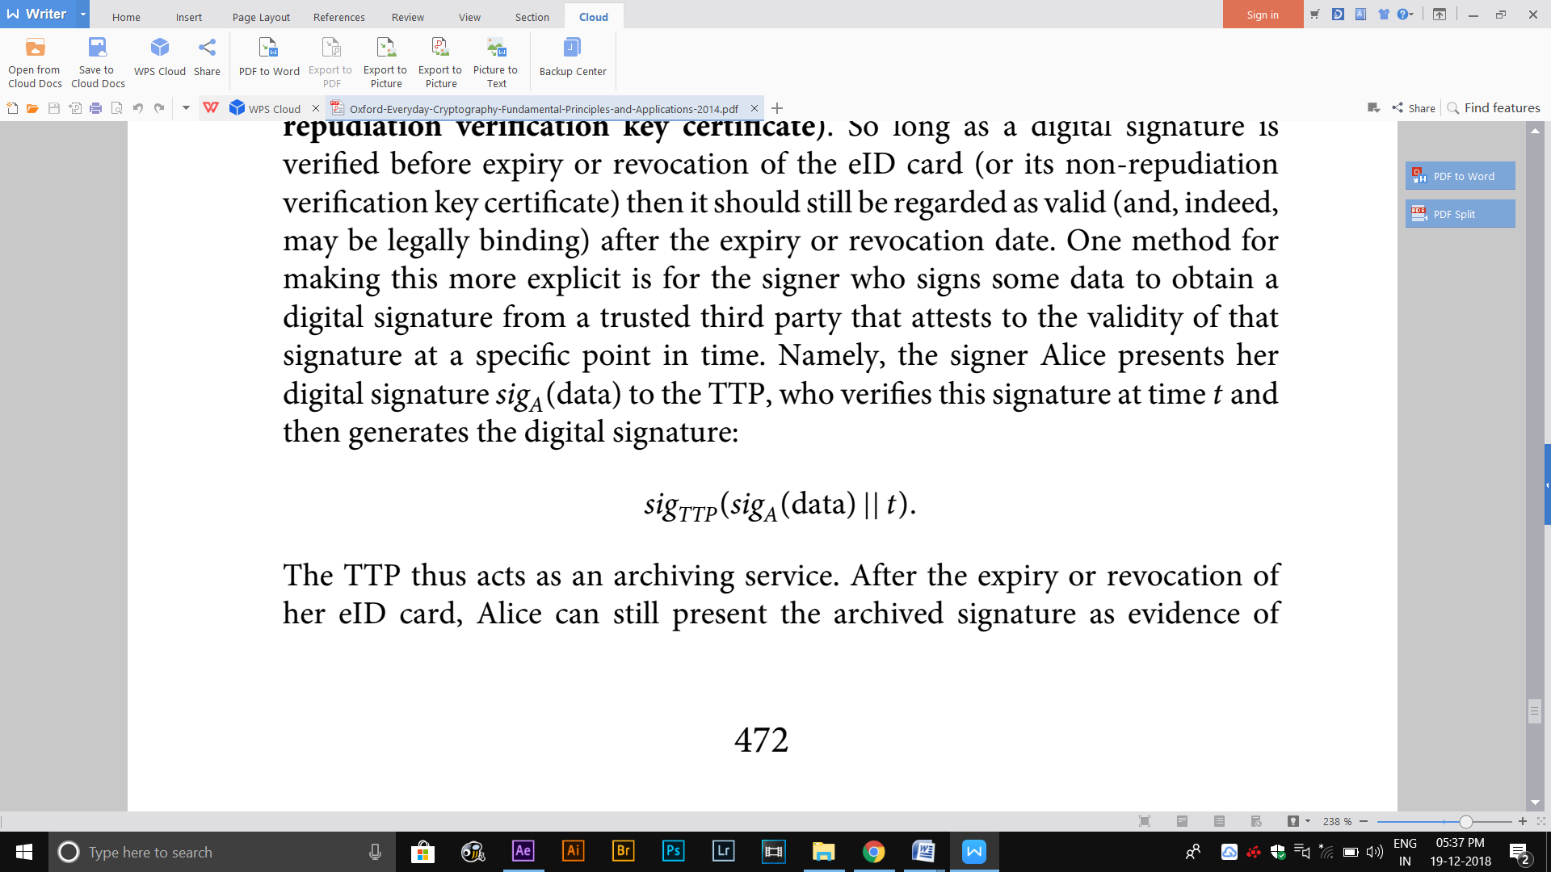

The TTP thus acts as an archiving service. After the expiry or revocation of her eID card, Alice can still present the archived signature as evidence of its validity. Note that any future relying party does not need to verify Alice’s original signature, but does have to trust the TTP. This process assumes that:

• The TTP’s verification key has a longer lifetime than Alice’s. On expiry of the TTP’s verification key, Alice can always ask the TTP to resign the archived signature with its new signature key.

• No flaws are subsequently found in any of the processes or algorithms used to generate or validate Alice’s digital signature.

**12.6.7 Design issues**

The main design issues concerning the eID card scheme are as follows:

**Use of public-key cryptography.** While eID cards are issued within a closed environment, they are intended for use in open environments. Thus the use of public-key cryptography is appropriate.

**Use of publicly known algorithms.** To increase confidence and support interoperability, the eID card scheme uses the well-respected RSA digital signature scheme.

**Use of certification hierarchies.** The eID card scheme’s national reach lends itself very naturally to a certification hierarchy, with central CAs supporting regional registration authorities.

**Specific data handling.** The eID card design demonstrates that in real applications different data items may require different management. This is reflected in the way that card data is digitally signed, which recognises that address data normally changes much more frequently than other types of personal data.

**Flexibility**. The eID card scheme is primarily an enabler for cryptographic applications. It therefore leaves specific applications a degree of flexibility on how they manage security of applications interacting with eID cards. In particular, applications must manage their own certificate revocation processing.

**12.7 Cryptography for home users**

**12.7.1 File protection**

There are two main reasons for a home user wanting to use cryptography to protect a file:

**Additional storage protection**. Most computer systems, including desktops, laptops, PDAs and smart phones, have basic security controls that provide some protection against unauthorised parties from accessing the files that are stored on them. Most home users rely on basic user access control mechanisms for this protection. The commonest such control is to provide entity authentication to the computer itself through the use of a passwordbased mechanism. However, such controls do not normally provide strong protection, since it is relatively easy to overcome them. In addition, different types of portable media exist for storing files, such as DVDs, memory cards and USB tokens, many of which have no default file storage protection mechanisms.

**File transfer security**. A user may wish to transfer a file from one computer system to another. While the end computer systems may be protected, the communication channel is potentially insecure.

**FULL DISK ENCRYPTION**

* One option for a home user who is concerned about the security of files stored on their desktop or laptop is to deploy full disk encryption, which encrypts every bit of data contained on the computer system.
* Full disk encryption mechanisms are available both in hardware and software, with hardware mechanisms typically offering greater security and performance.
* Full disk encryption is particularly attractive for laptops, which are at risk of becoming lost or stolen.
* The ‘classical’ physical attack on a stolen computer is for an attacker to remove the disk and reinstall it on a computer for which the attacker has administrator access.
* There are two constraints which motivate the type of encryption deployed in full disk encryption mechanisms:
* **Performance**. Encryption and decryption operations need to take place as fast as possible, ideally without any apparent delay. Thus most full disk encryption mechanisms encrypt each disk sector, which typically consist of around 512 bytes, independently.
* **Avoidance of storage overhead.** In order to use disk space efficiently, the encryption operation should not result in significantly more data being stored than would otherwise have been stored without full disk encryption.

**VIRTUAL DISK ENCRYPTION**

* An alternative to encrypting an entire disk is to use virtual disk encryption mechanisms, which can be used to encrypt chunks of data, usually referred to as containers.
* Virtual disk encryption can be deployed on devices such as USB tokens, as well as on desktops and laptops.
* In most solutions the user is required to authenticate to the device, usually by means of a password, in order to access the encrypted files within the container.
* There are several advantages of virtual disk encryption over full disk encryption:
* Virtual disk encryption can be used to encrypt selected data on a disk, rather than the full disk.
* An encrypted container is normally portable, in the sense that it can be copied onto media such as a DVD. Thus virtual disk encryption can provide security for data transfer, as well as storage, in cases where the data can be physically transferred using portable media. Just as for full disk encryption, care needs to be taken to make sure that the mechanisms and processes used to support user (entity) authentication to the device and key management are adequately addressed.

**FILE ENCRYPTION**

* The greatest granularity of control over data encryption is to deploy file encryption, which encrypts individual files (or folders).
* One of the other main advantages of file encryption is that it can protect a file on a running computer system that an attacker has gained access to.
* Contrast this situation with, for example, a full disk encryption mechanism running on a computer that the user has authenticated to and then (foolishly) walked off and left unattended.
* Unlike full and virtual disk encryption, however, file (and folder) encryption do not normally prevent an attacker from learning data associated with the file, such as file size, file type and the folder name in which the file resides.
* Some operating systems provide in-built file encryption, such as the Encrypting File System (EFS) deployed in many Microsoft operating systems.
* EFS uses hybrid encryption to protect a file by first encrypting it with a unique symmetric key, which is then itself encrypted using the user’s public key. The user’s private key is then required in order to decrypt.
* One issue with in-built file encryption of this type is that the protection is not always maintained when the encrypted file is transferred to another storage medium.
* However, there are many third-party software applications providing general file encryption capability, some of which support transfer of encrypted data.
* File encryption is also appropriate for a user who only occasionally needs to encrypt a file, usually for transfer purposes.
* An example of encryption software for casual encryption of this type is GNU Privacy Guard (GPG). This uses hybrid encryption to encrypt files, as well as supporting digital signatures.
* A range of patent-free symmetric and public-key algorithms are supported. Users generate their own key pairs locally, using a passphrase to generate, and later activate, a key encrypting key that is used to protect the decryption key.
* Public-key management is lightweight and left at the user’s discretion. Users could, for example, exchange public keys directly with known contacts or use a web of trust .
* Finally, some application software supports encryption for specific data formats. For example, Adobe software allows users to encrypt pdf files. Adobe originally used RC4 but now also supports AES. The key is activated using a password, which can be sent to the recipient of an encrypted file in order to allow them to decrypt and view it.

**12.7.2 Email security**

EMAIL SECURITY REQUIREMENTS

There are two potential concerns about the security of email:

**Confidentiality.** By default, email messages are unprotected during their transfer from the email sender’s device to the email receiver’s device. During that transfer the email message resides on several email servers and internet routers, as well as passing through various potentially unprotected networks. There are many points at which, at least in theory, the contents of an email message could be viewed by someone other than the intended recipient. In addition, users sometimes mistakenly send email to the wrong recipient, for example, by replying to all the recipients of an email rather than just the original sender. Thus there is certainly a case that could be made for requiring confidentiality of some types of email message.

**Data origin authentication.** Email messages are structured using a simple protocol that facilitates their transfer. This protocol includes fields for specifying the sender, recipient and subject, as well as the message itself. An informed attacker can fairly easily generate forged emails. In addition, at most of the points at which an attacker can read a genuine email, the attacker could intercept and make changes to the email message before forwarding it on to the recipient. This also makes a case for requiring data origin authentication of email messages. Indeed, for some email messages we might even want to go further and require non-repudiation, but data origin authentication probably suffices for most traffic.

**EMAIL SECURITY APPLICATIONS**

* There are two well-known standards for protection of email, each of which are implemented by a wide range of email security applications.
* Both Open Pretty Good Privacy (OpenPGP) and Secure/Multipurpose Internet Mail Extensions (S/MIME) broadly work in the same way, although precise implementations may have minor differences.
* They both provide confidentiality and data origin authentication (non-repudiation) through support for encryption and digital signatures.
* They are either supported by default in certain email clients or can be installed through plug-ins.
* There are three ways in which email messages can be protected using these applications:
* **Confidentiality only**. This is provided by hybrid encryption. The symmetric encryption key is either generated using a deterministic generator or a software-based non-deterministic generator. The body of the email message is then encrypted using this symmetric key, and the symmetric key is encrypted using the public key of the recipient. Data origin authentication only. This is provided by a digital signature scheme with appendix .The email message is first hashed and then signed using the signature key of the sender. The receiver will need to obtain the corresponding verification key in order to verify the resulting digital signature.
* **Confidentiality and data origin authentication.** This is typically provided by following the MAC-then-encrypt construction. In other words, a symmetric encryption key is generated and the email message is digitally signed, as described above. The email message and the resulting signature are then both encrypted using the symmetric encryption key. Finally the symmetric encryption key is itself encrypted using the public encryption key of the recipient.

The main differences between OpenPGP and S/MIME are with respect to:

**Cryptographic algorithms supported.** OpenPGP implementations support a range of cryptographic algorithms. On the other hand, S/MIME is more restrictive and specifies the use of AES or Triple DES for symmetric encryption and RSA for digital signatures and public-key encryption (the original S/MIME proposal came from RSA Data Security Inc.).

**Public-key management.** Again, OpenPGP is more flexible and can be supported by almost any form of public-key management system. The default public key management model for OpenPGP is to use a web of trust, although more formal public-key management can also be supported. On the other hand, S/MIME is based on the use of X.509 Version 3 certificates supported by a structured public-key management system relying on Certificate Authorities.

**AN ALTERNATIVE APPROACH TO EMAIL SECURITY**

* Since the approaches to email security rely on the use of public-key cryptography, the problem of assurance of purpose of public keys needs to be addressed by whichever public-key management system is used to support an email security application.
* The IDPKC concept requires unique identifiers that can be associated with users of the system.
* In email security applications such a potential unique identifier exists in the form of the email address of the recipient. Thus, using IDPKC, an email sender is potentially able to send an encrypted email to any recipient simply by encrypting the email using the recipient’s email address.
* The advantages offered by this concept have resulted in the commercial development of email security applications based on IDPKC.
* one of the potential drawbacks with IDPKC is the need for an online centrally-trusted key centre (TKC). Thus IDPKC is most suited to large organisations where such a TKC can easily be provided, rather than home users.
* However, a home user could well receive encrypted email from such an organisation without needing any formal relationship with the sender. In this case:

